نموذج أسئلة و اجابة مادة ميكانيكا الموائع م 1111
أستاذ المادة: الدكتور محمد عبد اللطيف الشرنوبى
تاريخ الامتحان: الأحد 30 ديسمبر 2018


Benha University
College of Engineering at Benha

Department of Mechanical Eng.
Subject: Fluid Mechanics
Model Answer of the Final Corrective Exam
Date of the Exam Dec/30/2018 Time: 180 min
Elaborated by: Dr. Mohamed Elsharnoby
1-a) i) vapor pressure ii) surface tension iii) Newtonian fluid give example iv) Viscoelastic fluid and give example v) streak line and time lines
b) Eight kilometers below the surface of the ocean the pressure is 81.7 MPa. Determine the density of seawater at this depth if the density at the surface is 1025 kg/m³ and the average bulk modulus of elasticity is 2.34 GPa. The atmospheric pressure at the surface may be taken as 1 bar. What is the specific gravity at this depth?
c) A hydrogen-filled balloon expands to a sphere of 20 m diameter at a height of 30 km, where the absolute pressure is 1100 Pa and the temperature is -40ºC. What is the volume of the balloon at ground level, where the absolute pressure is 101.3 kPa and the temperature is 15ºC? (Note that the volume of a sphere = (4/3)π r³.)
2-a) A solid cylinder of diameter D, length L, density ρ_{s} falls due to gravity inside a tube of diameter Do. The clearance, (Do-D) <<D, is filled with a film of viscous fluid (ρ, µ). Derive a formula for terminal fall velocity and apply to SAE 30 oil at 20°C for a steel cylinder with D = 2 cm, Do = 2.04 cm, and L = 15 cm. Neglect the effect of any air in the tube. Given : µ for oil = 2.9 Poise, S.G for steel is 7.85
b) For the compound manometer shown in Fig.1 , find the pressure at B in psi and in mmHg if the pressure at A is 1bar. Given ρ _{(Kerosine)} = 804 kg/ m³ and ρ _{(Benzene)} = 881 kg/ m³ .
c) Find the force P needed to hold the 10 m long cylindrical object in position as shown in Fig.2.
3-a) The tank of water in Fig.3 is moving with constant acceleration up a 30º inclined plane. Compute (i) the acceleration a ,(ii) whether the acceleration is up or down, and ( the maximum pressure in the tank.
b)Define center of buoyancy, metacenter, metacentric height, metacentric radius and explain the stability of floating bodies.
c) Consider the two-dimensional incompressible velocity potential ϕ= xy + x² – y².
(i) Is it true that ∇²ϕ = 0, and, if so, what does this mean? (ii) If it exists, find the stream function Ψ(x, y) of this flow. (iii) Find the equation of the streamline which passes through (x, y) = (2, 1).
4-a) An idealized velocity field is given by the formula V=4txi-2t²y+4xzk
Is this flow field steady or unsteady? Is it two- or three-dimensional? At the point (x, y, z) = (–1, +1, 0), compute (a) the acceleration vector and (b) any unit vector normal to the acceleration.
b) A water is flowing from two orifices at the side of a large tank. The orifice (A) is at depth of 10 m and the orifice B is exactly above A and at a depth of 6 m. The water jets are horizontally flowing from both orifices as shown in Fig.4. Assume the origin is at orifice A, find the location of intersection (C) of the two jets.
5-a) One hundred liters per second of water are flowing as shown in Fig.5 . Calculate the pump power assuming no losses
b ) Deduce an expression for the discharge of water over a right-angled sharp edged V-notch, given that the coefficient of discharge is 0.61.
A rectangular tank 16m by 6m has the same notch in one of its short vertical sides, Fig.6. Determine the time taken for the head, measured from the bottom of the notch, to fall from 15cm to 7.5cm.
* * * G O O D L U C K * * *

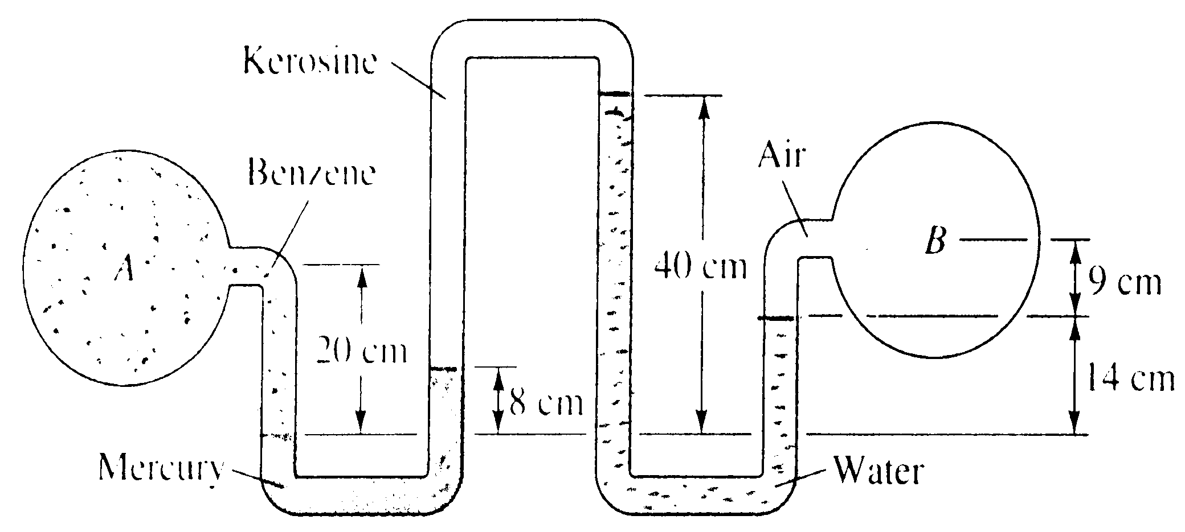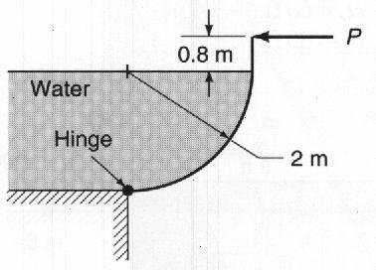

Figure 1 Figure 2

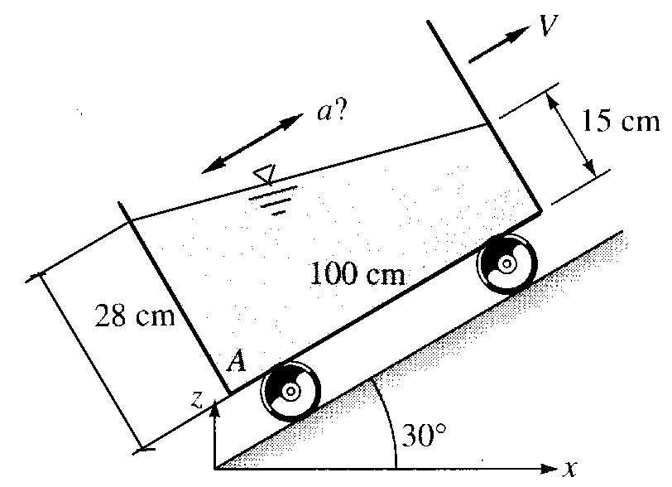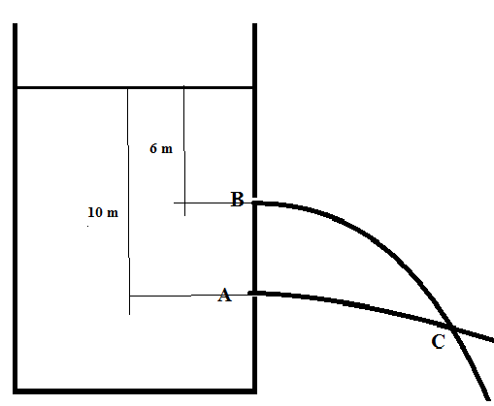

Figure 3 Figure 4

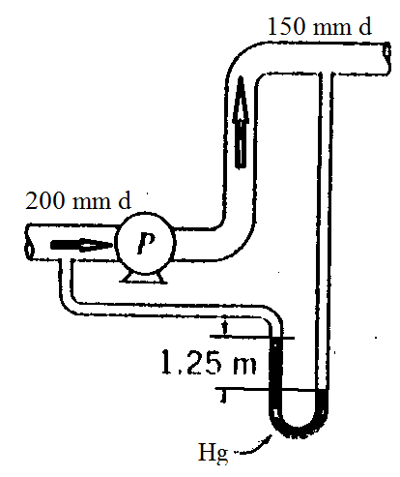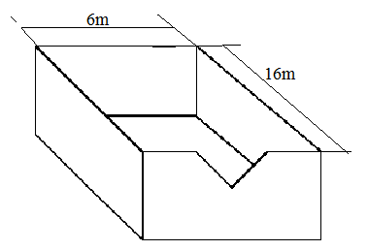
Figure 5 Figure 6

1-a) i) Vapor pressure is pressure at which liquid boils, or pressure of vapor above liquid at equilibrium state.
ii) Surface tension is a phenomena that makes the interface between two fluids or between liquid and water behaves as elastic membrane.
iii) Fluids which obey the Newton's law of viscosity are called as Newtonian fluids. Newton's law of viscosity is given by
τ = μ du/dy, where τ = shear stress and μ = viscosity of fluid
du/dy = shear rate, rate of strain or velocity gradient
All gases and most liquids which have simpler molecular formula and low molecular weight such as water, benzene, ethyl alcohol, CCl₄, hexane and most solutions of simple molecules are Newtonian fluids.
iii) Streakline is a line passing through fluid particles originated from a given point ( have earlier passed through a certain point in the flow field, Timelines are lines connecting specified particles at different time instants.
iv) Visco-elastic fluids: Some fluids have elastic properties, which allow them to spring back when a shear force is released. e.g. egg white.
v) Streakline is a line passing through fluid particles originated from a given point ( have earlier passed through a certain point in the flow field, Timelines are lines connecting specified particles at different time instants.
1-b) Bulk modulus $E_{v}=\frac{\text{ΔP}}{\frac{\text{Δρ}}{ρ}}=\frac{\text{81}\text{.}7×{\text{10}}^{6}−{\text{10}}^{5}}{\frac{\text{Δρ}}{\text{1025}}}=2\text{.}\text{34}×{\text{10}}^{9}$ N/m² $→\text{Δρ}=\text{35}\text{.}{\text{74kg/m}}^{3}$
$∴ρ$at the depth of eight kilometers = 1025+35.74 = 1060.74 kg/m³.
Specific gravity S.G = $\frac{ρ}{\text{1000}}=1\text{.}\text{06074}$
1-c) 2-a) $\frac{P_{1}V_{1}}{T_{1}}=\frac{P_{2}V_{2}}{T_{2}}$
$$V_{1}=\frac{4}{3}{\text{πr}}^{3}=\frac{4}{3}π×{\text{10}}^{3}=\text{4188}\text{.}{\text{79m}}^{3}$$
$P_{1}={\text{1100Pa,T}}_{1}={\text{233K,P}}_{2}={\text{103000Pa,T}}_{2}=\text{288K}$ $→V_{2}=\text{56}\text{.}{\text{22m}}^{3}$

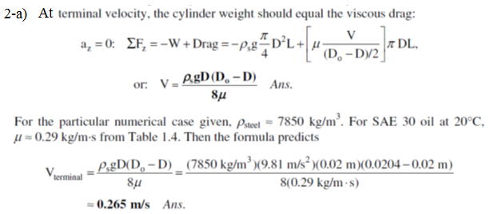

2-b
Figure 1
From figure 2 above we have:
$\begin{aligned}P_{A}+ρ_{k}g(0\text{.}2)−ρ_{\text{Hg}}g(0\text{.}\text{08})+ρ_{w}g(0\text{.}4)−ρ_{w}g(0\text{.}\text{14})=P_{B} \\ ∴P_{B}={\text{10}}^{5}+\text{804}×9\text{.}\text{81}×0\text{.}2−\text{13600}×9\text{.}\text{81}×0\text{.}\text{08}+\text{9810}×0\text{.}\text{26} \\ ∴P_{B}=\text{93454}\text{.}\text{77}\text{Pa}=0\text{.}\text{9345477}\text{bar} \\ ∴P_{B}=\text{13}\text{.}\text{55}\text{psi}\end{aligned}$2-b)
2-c)
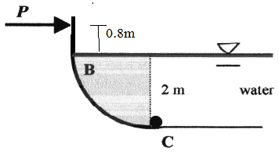
Figure 2
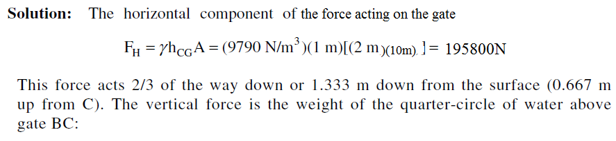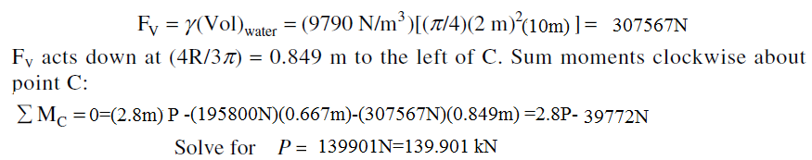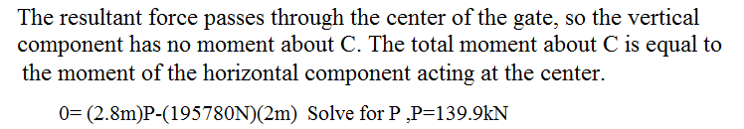
3-a)
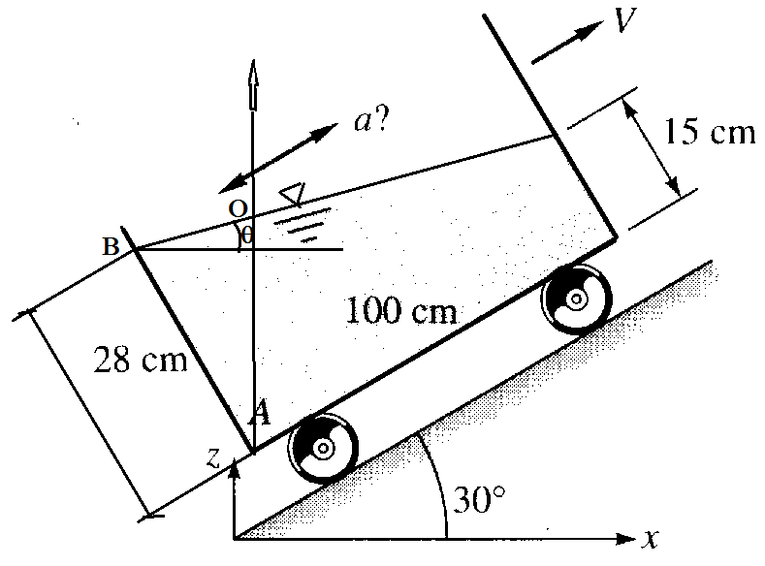
The angle of the free surface with the horizontal is θ = 30º-tan⁻¹0.13=
The angle is positive so the acceleration is down.
tanθ=dz/dx=-a_{x}/(g+a_{z}), a_{x} = a cos 30º, a_{z} =a sin30º
Maximum pressure is at A
Draw a vertical line passing through A that intersect the surface at O
The pressure at A = ρgh, where h is the distance OA
OA/sin(60º+θ)=0.28/sin(90º-θ)
OA=
P_{A}=

3-b) There are two cases
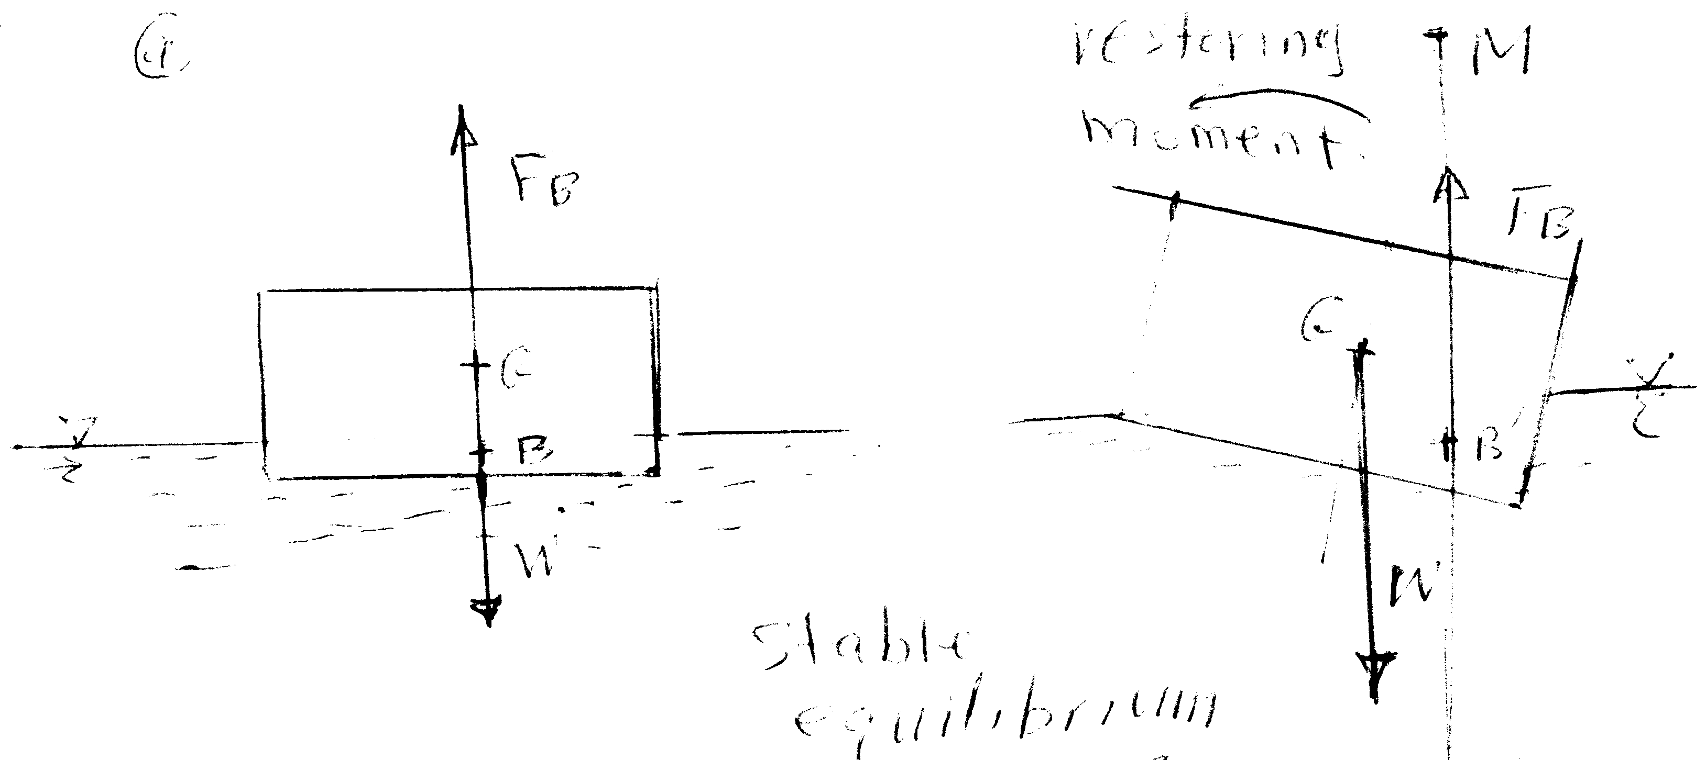
Figure 3-a
Case 1: Stable equilibrium , when the floating body is tilted to the right, a couple is created due to the deviation between the lines of actions of weight and buoyant force. This moment restore the body to its original position when the metacenter, M, is above the center of gravity, G.(figure 3-a)
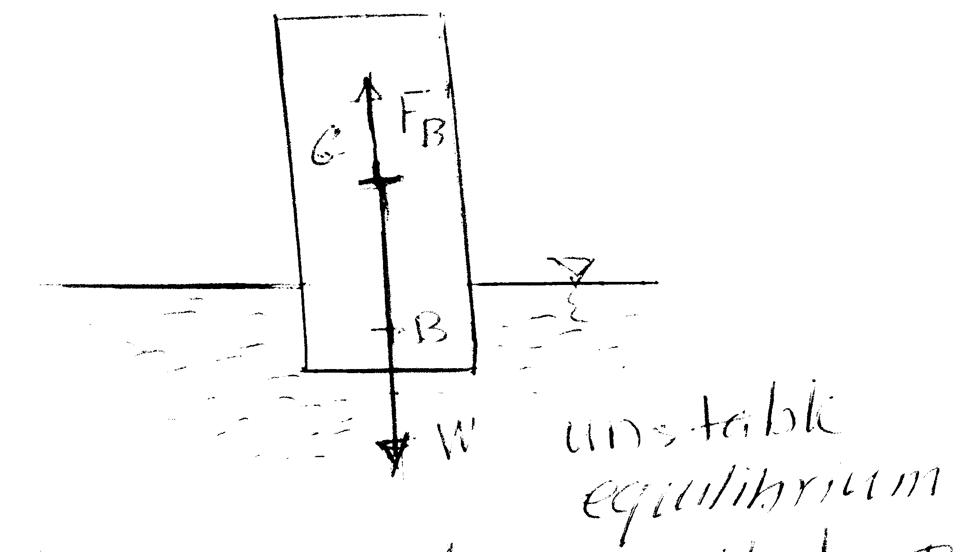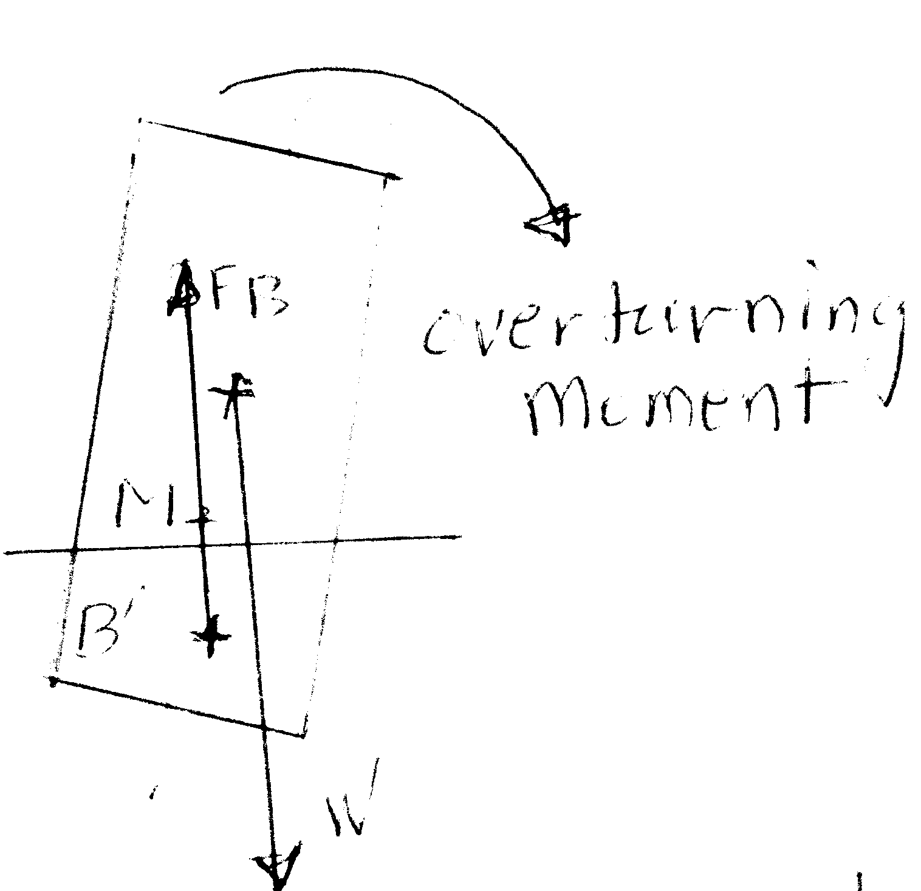
Figure 3-b
Case 2: Unstable equilibrium , when the floating body is tilted to the right, a couple is created due to the deviation between the lines of actions of weight and buoyant force. This moment turn the body over to when the metacenter, M, is below the center of gravity, G.

1-c) $μ=7\text{.}2×{\text{10}}^{−1}=0\text{.}\text{72}{\text{kg}}/m\text{.}s$
$$τ=μ\frac{\text{du}}{\text{dy}}→\text{du}=\text{rw}=\frac{r(2πn)}{\text{60}}=\frac{0\text{.}\text{18}x2πx\text{200}}{\text{60}}=3\text{.}\text{77}m$$
$$τ=μ\frac{\text{du}}{\text{dy}}→τ=0\text{.}\text{72}×\frac{3\text{.}\text{77}}{1\text{.}5×{\text{10}}^{−4}}=\text{18096}\text{Pa}$$
$$\begin{aligned}F=\text{τA}=\text{τπ}\text{DL}→F=\text{20466}N \\ \text{Power}=\text{Fr}ω=\text{77155}W\end{aligned}$$
2-a) The compressibility of the fluid is given by: $k=\frac{1}{ρ}\frac{dρ}{\text{dp}}$
For isentropic process $\frac{p}{ρ^{γ}}=C$$→\frac{\text{dp}}{dρ}=C{\text{γρ}}^{γ−1}=\frac{p}{ρ^{γ}}{\text{γρ}}^{γ−1}$$→\frac{\text{dp}}{dρ}=\frac{γp}{ρ}$
$∴$the isentropic compressibility $k_{s}=\frac{1}{ρ}\frac{ρ}{\text{γp}}=\frac{1}{\text{γp}}$
2-b) Solution: The total beam volume is 3(.1)2 = 0.03 m³, and therefore its weight is W = (0.65)(9790)(0.03) = 190.9 N, acting at the centroid, 1.5 m down from point A. Meanwhile, if the submerged length is H, the buoyancy is B = (9790)(0.1)²H = 97.9H Newton, acting at H/2 from the lower end. Sum moments about point A:
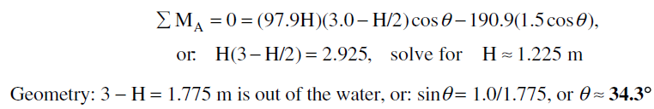
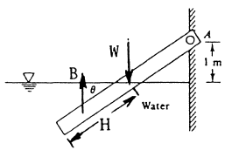
FIGURE 4

2-c
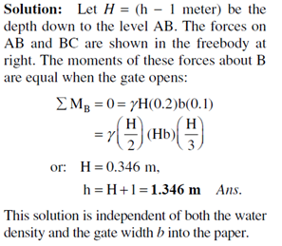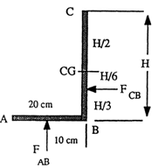

Figure 5
3-a) Solution
Part i) The cup contains 7 cm of coffee. The remaining distance of 3 cm up to the lip must equal the distance h/2 in next figure.. Thus
Solving we obtain
To compute the pressure, it is convenient to put the origin of coordinates r and z at the bottom
of the free-surface depression, as shown in Fig.. The gage pressure here is p_{o}=0, and
point A is at (r, z)= (3 cm, _4 cm). We can then evaluate

Figure 6
3-b)Center of Bouncy is the point of action of the up thrust acting on the floating or immersed bodies..
A vertical line drawn upward from B_ intersects the line of symmetry at a point M, called the metacenter.
Stability of floating bodies
There are two cases
Figure 7-a
Case 1: Stable equilibrium , when the floating body is tilted to the right, a couple is created due to the deviation between the lines of actions of weight and buoyant force. This moment restore the body to its original position when the metacenter, M, is above the center of gravity, G.(figure 7-a)
Figure 7-b
Case 2: Unstable equilibrium, when the floating body is tilted to the right, a couple is created due to the deviation between the lines of actions of weight and buoyant force. This moment turn the body over to when the metacenter, M, is below the center of gravity, Figure 7-b

3-c)
c) ) i-
$$\begin{aligned}\vec{V}=(x^{2}−y^{2}+x)i−(\text{2xy}+y)j \\ \vec{V}=\text{ui}+\text{vj}→→u=x^{2}−y^{2}+\text{x,v}=−(\text{2xy}+y) \\ \text{the acceleration \{}\vec{a}\end{aligned}=a_{x}i+a_{y}ja_{x}=\frac{∂u}{∂t}+u\frac{∂u}{∂x}+v\frac{∂u}{∂y}→→a_{x}=(x^{2}−y^{2}+x)(\text{2x}+1)+−(\text{2xy}+y)(\text{-2y})={\text{2x}}^{3}+{\text{2xy}}^{2}+x+3x^{2}+y^{2}a_{y}=\frac{∂v}{∂t}+u\frac{∂v}{∂x}+v\frac{∂v}{∂y}→→a_{y}=(x^{2}−y^{2}+x)(\text{-2y})+−(\text{2xy}+y)(\text{-2x-1}))={\text{2y}}^{3}+{\text{2yx}}^{2}+2\text{xy}+ya_{x}=\text{18},a_{y}=\text{26}→\vec{a}=\text{18}i+\text{26}j$$
ii) The flow will represent a physical flow if $\frac{∂u}{∂x}+\frac{∂v}{∂y}=0$, for this flow we have $\frac{∂u}{∂x}+\frac{∂v}{∂y}$$=\text{2x}+1−(\text{2x}+1)=0$ $∴$The flow is a physical flow.

iii) $u=x^{2}−y^{2}+x=\frac{∂ψ}{∂y}→ψ=x^{2}y−\frac{y^{3}}{3}+\text{xy}+f(x)$
$$\begin{aligned}v=−\text{2xy-y}=−\frac{∂ψ}{∂x}→ψ=x^{2}y+\text{xy}+g(y) \\ ∴ψ=x^{2}y−\frac{y^{3}}{3}+\text{xy}\end{aligned}$$
$$u=x^{2}−y^{2}+x=\frac{∂φ}{∂x}→φ=−y^{2}x+\frac{x^{3}}{3}+\frac{x^{2}}{2}+g(y)$$
$$v=−\text{2xy-y}=\frac{∂φ}{∂y}→φ=−{\text{xy}}^{2}−\frac{y^{2}}{2}+f(x)$$
$φ=−y^{2}x+\frac{x^{3}}{3}+\frac{x^{2}}{2}+$$−\frac{y^{2}}{2}$
iv) The vorticity is given by : $\frac{∂v}{∂x}−\frac{∂u}{∂y}=−\text{2y}+\text{2y}=0$
4-a)i)
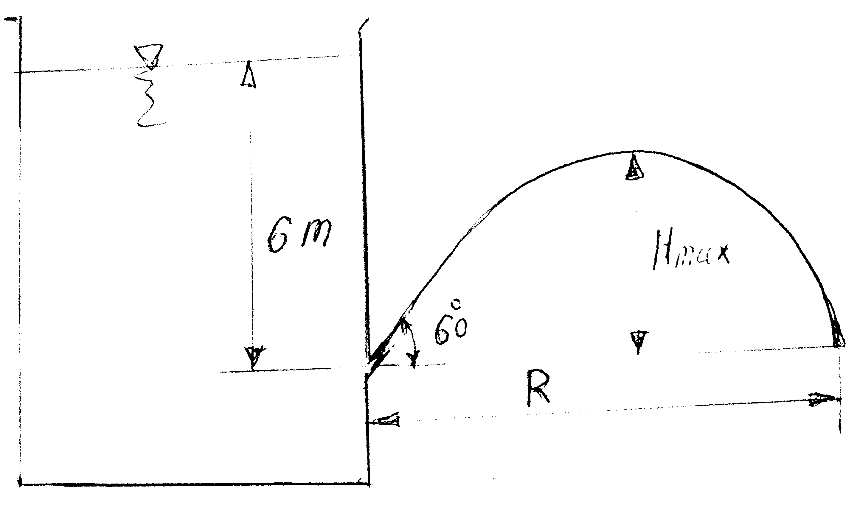
Figure 7
The maximum height H_{max} is given from the relation;
H_{max} = H sin²θ = 6.0x0.25 = 1.5 m;
The range R is given by the equation: $R=\text{2Hsin2θ}→R=2×6×{\text{sin60}}^{∘}$
$$R=6\sqrt{3}=\text{10}\text{.}\text{392m}$$
ii) The time to empty the tank is calculated as follows:
$$\begin{aligned}{\text{-A}}_{T}\frac{\text{dh}}{\text{dt}}=C_{d}A_{o}\sqrt{\text{2gh}}→\text{dt}=−\frac{A_{T}}{C_{d}A_{o}\sqrt{\text{2g}}}\frac{\text{dh}}{\sqrt{h}} \\ t=−\frac{A_{T}}{C_{d}A_{o}\sqrt{\text{2g}}}\int_{6}^{0}{\frac{\text{dh}}{\sqrt{h}}=}−\frac{{\text{2A}}_{T}\sqrt{h}}{C_{d}A_{o}\sqrt{\text{2g}}}↕_{6}^{0}→t=1\text{382}\text{.}5\text{sec}\end{aligned}$$
4-b)
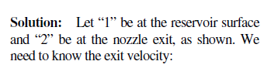
As shown in Figure 8
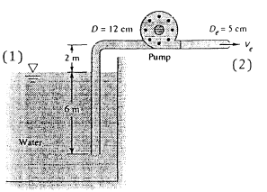
Figure 8
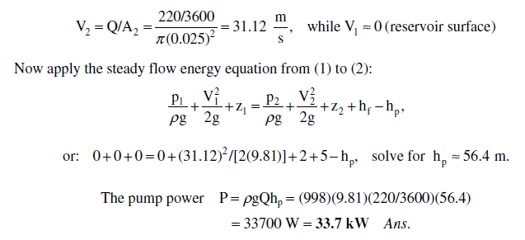
5-a)
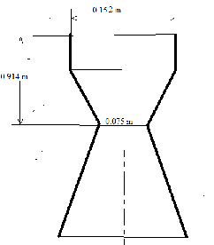
Figure 9
From the question:
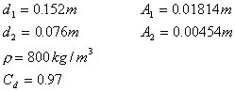
Apply Bernoulli:
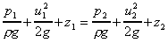
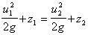
By continuity:
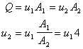
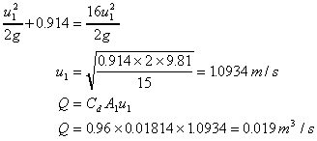
ii)
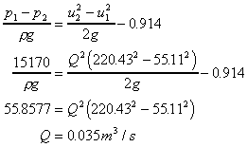
5-b)

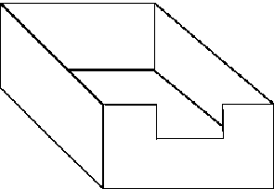
From the question A = 60 000 m², Q = 0.678 h ^{3/2}
Write the equation for the discharge in terms of the surface height change:
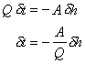Integrating between h₁ and h_{2,} to give the time to change surface level
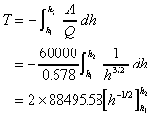
From the question T = 3600 sec and h₁ = 0.6m
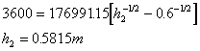
Total depth = 3.4 + 0.58 = 3.98m

