
Benha University
College of Engineering at Benha

Department of Mechanical Eng.
مادة ميكانيا الموائع كود م 1111 Subject: Fluid Mechanics
Model Answer of the Final Corrective Exam
Date of the Exam January/4/2016
تاريخ الامتحان الاثنين 4 يناير 2015
استاذ المادة أ.د محمد عبد اللطيف الشرنوبى
Elaborated by: Dr. Mohamed Elsharnoby

1-a) i) Thixotropic fluids: for which the dynamic viscosity decreases with the time for which shearing forces are applied. e.g. thixotropic jelly paints.
Rheopectic fluids: Dynamic viscosity increases with the time for which shearing forces are applied. e.g. gypsum suspension in water.
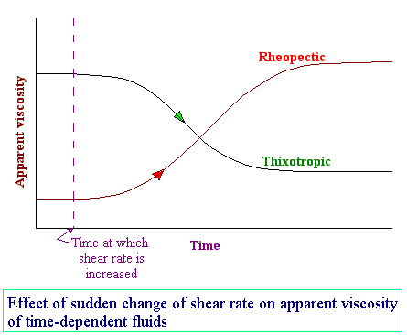
Figure 1
ii) Surface tension is a phenomena that makes the interface between two fluids or between liquid and water behaves as elastic membrane.
iii) Streakline is a line passing through fluid particles originated from a given point ( have earlier passed through a certain point in the flow field, Timelines are lines connecting specified particles at different time instants.
iv) Visco-elastic fluids: Some fluids have elastic properties, which allow them to spring back when a shear force is released. e.g. egg white.
v) Potential flow: Flow whose vorticity equal zero or Curl V = 0
vi) where the vector operation () is referred to as the curl of the velocity vector V. The vorticity vector, ζ, is defined as twice the rotation vector:
vii) Circulation is defined as the line integral around the curve of the arc length ds times the tangential component of velocity. Shear stress for the element is thus given by
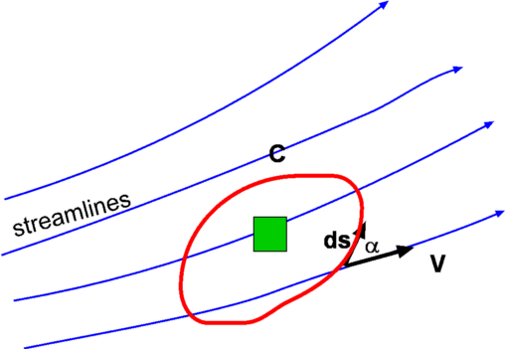
Figure 2: Definition of Circulation
1-b) The relationship between shear stress and the velocity gradient (rate of shear strain) in the fluid. These relationships can be seen in the graph below for several categories
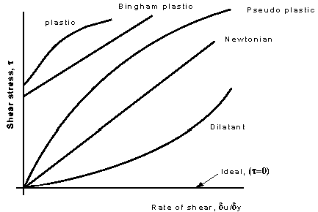
Figure 3 Shear stress vs. Rate of shear strain δu/δy
Newtonian fluids:
Fluids which obey the Newton's law of viscosity are called as Newtonian fluids. Newton's law of viscosity is given by
τ = μ du/dy, where τ = shear stress and μ = viscosity of fluid
du/dy = shear rate, rate of strain or velocity gradient
All gases and most liquids which have simpler molecular formula and low molecular weight such as water, benzene, ethyl alcohol, CCl₄, hexane and most solutions of simple molecules are Newtonian fluids.
Properties are independent of time under shear.
Bingham-plastic: Resist a small shear stress but flow easily under larger shear stresses. e.g. tooth-paste, jellies, and some slurries.
Pseudo-plastic:
Most non-Newtonian fluids fall into this group . No minimum shear stress necessary and the viscosity decreases with rate of shear, e.g. polymer solutions, blood, colloidal substances like clay, milk and cement.. Pseudo plastic fluids are also called as Shear thinning fluids. At low shear rates (du/dy) the shear thinning fluid is more viscous than the Newtonian fluid, and at high shear rates it is less viscous.
  - Dilatant fluids: Viscosity increases with increasing velocity gradient. They are uncommon, but suspensions of starch and sand behave in this way. Dilatant fluids are also called as shear thickening fluids. ; Viscosity increases with rate of shear e.g. quicksand.
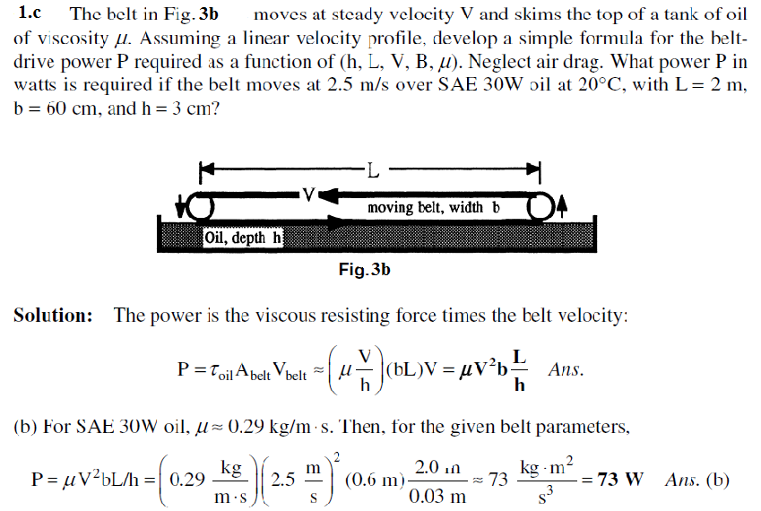
2-a) Solution: The total beam volume is 3(.1)2 = 0.03 m³, and therefore its weight is W = (0.65)(9790)(0.03) = 190.9 N, acting at the centroid, 1.5 m down from point A. Meanwhile, if the submerged length is H, the buoyancy is B = (9790)(0.1)²H = 97.9H Newton, acting at H/2 from the lower end. Sum moments about point A:
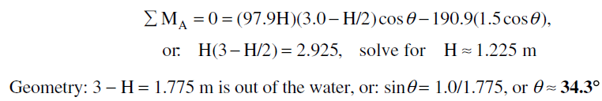
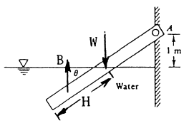
Figure 4
2.b
$\begin{aligned}P_{A}+ρ_{\text{Benzene}}g(0\text{.}2)−ρ_{\text{Hg}}g(0\text{.}\text{08})−ρ_{\text{kerosene}}g(0\text{.}\text{32})+ρ_{w}g(0\text{.}\text{26})=P_{B} \\ ∴P_{B}=P_{A}+\text{840}×9\text{.}\text{81}×0\text{.}2−\text{13600}×9\text{.}\text{81}×0\text{.}\text{08}−0\text{.}\text{804}x\text{9810}×0\text{.}\text{32}+\text{9810}x0\text{.}\text{26} \\ ∴P_{B}−P_{A}=−0\text{.}\text{08997}\text{bar}=−\text{8997}\text{Pa}\end{aligned}$
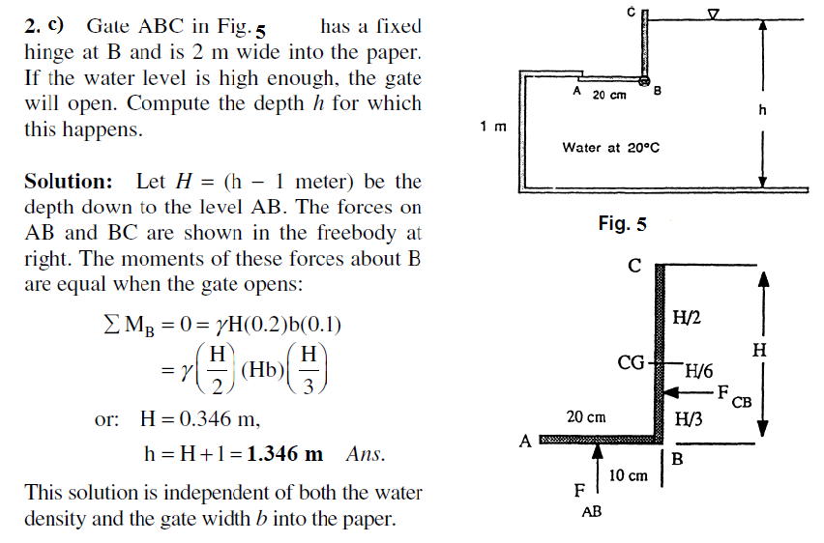
3-a) Solution
Part i) The cup contains 7 cm of coffee. The remaining distance of 3 cm up to the lip must equal the distance h/2 in next figure.. Thus
Solving we obtain
To compute the pressure, it is convenient to put the origin of coordinates r and z at the bottom
of the free-surface depression, as shown in Fig.. The gage pressure here is p_{o}=0, and
point A is at (r, z)= (3 cm, _4 cm). We can then evaluate

Figure 6
3-b)Center of Bouncy is the point of action of the up thrust acting on the floating or immersed bodies..
A vertical line drawn upward from B_ intersects the line of symmetry at a point M, called the metacenter.
Stability of floating bodies
There are two cases
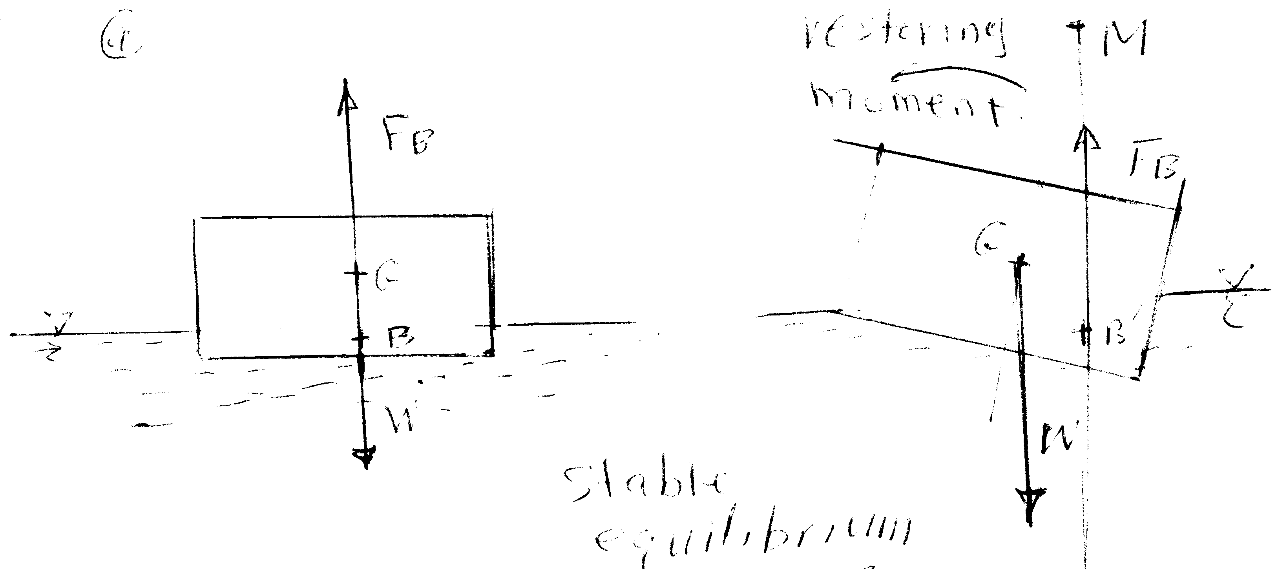
Figure 7-a
Case 1: Stable equilibrium , when the floating body is tilted to the right, a couple is created due to the deviation between the lines of actions of weight and buoyant force. This moment restore the body to its original position when the metacenter, M, is above the center of gravity, G.(figure 7-a)
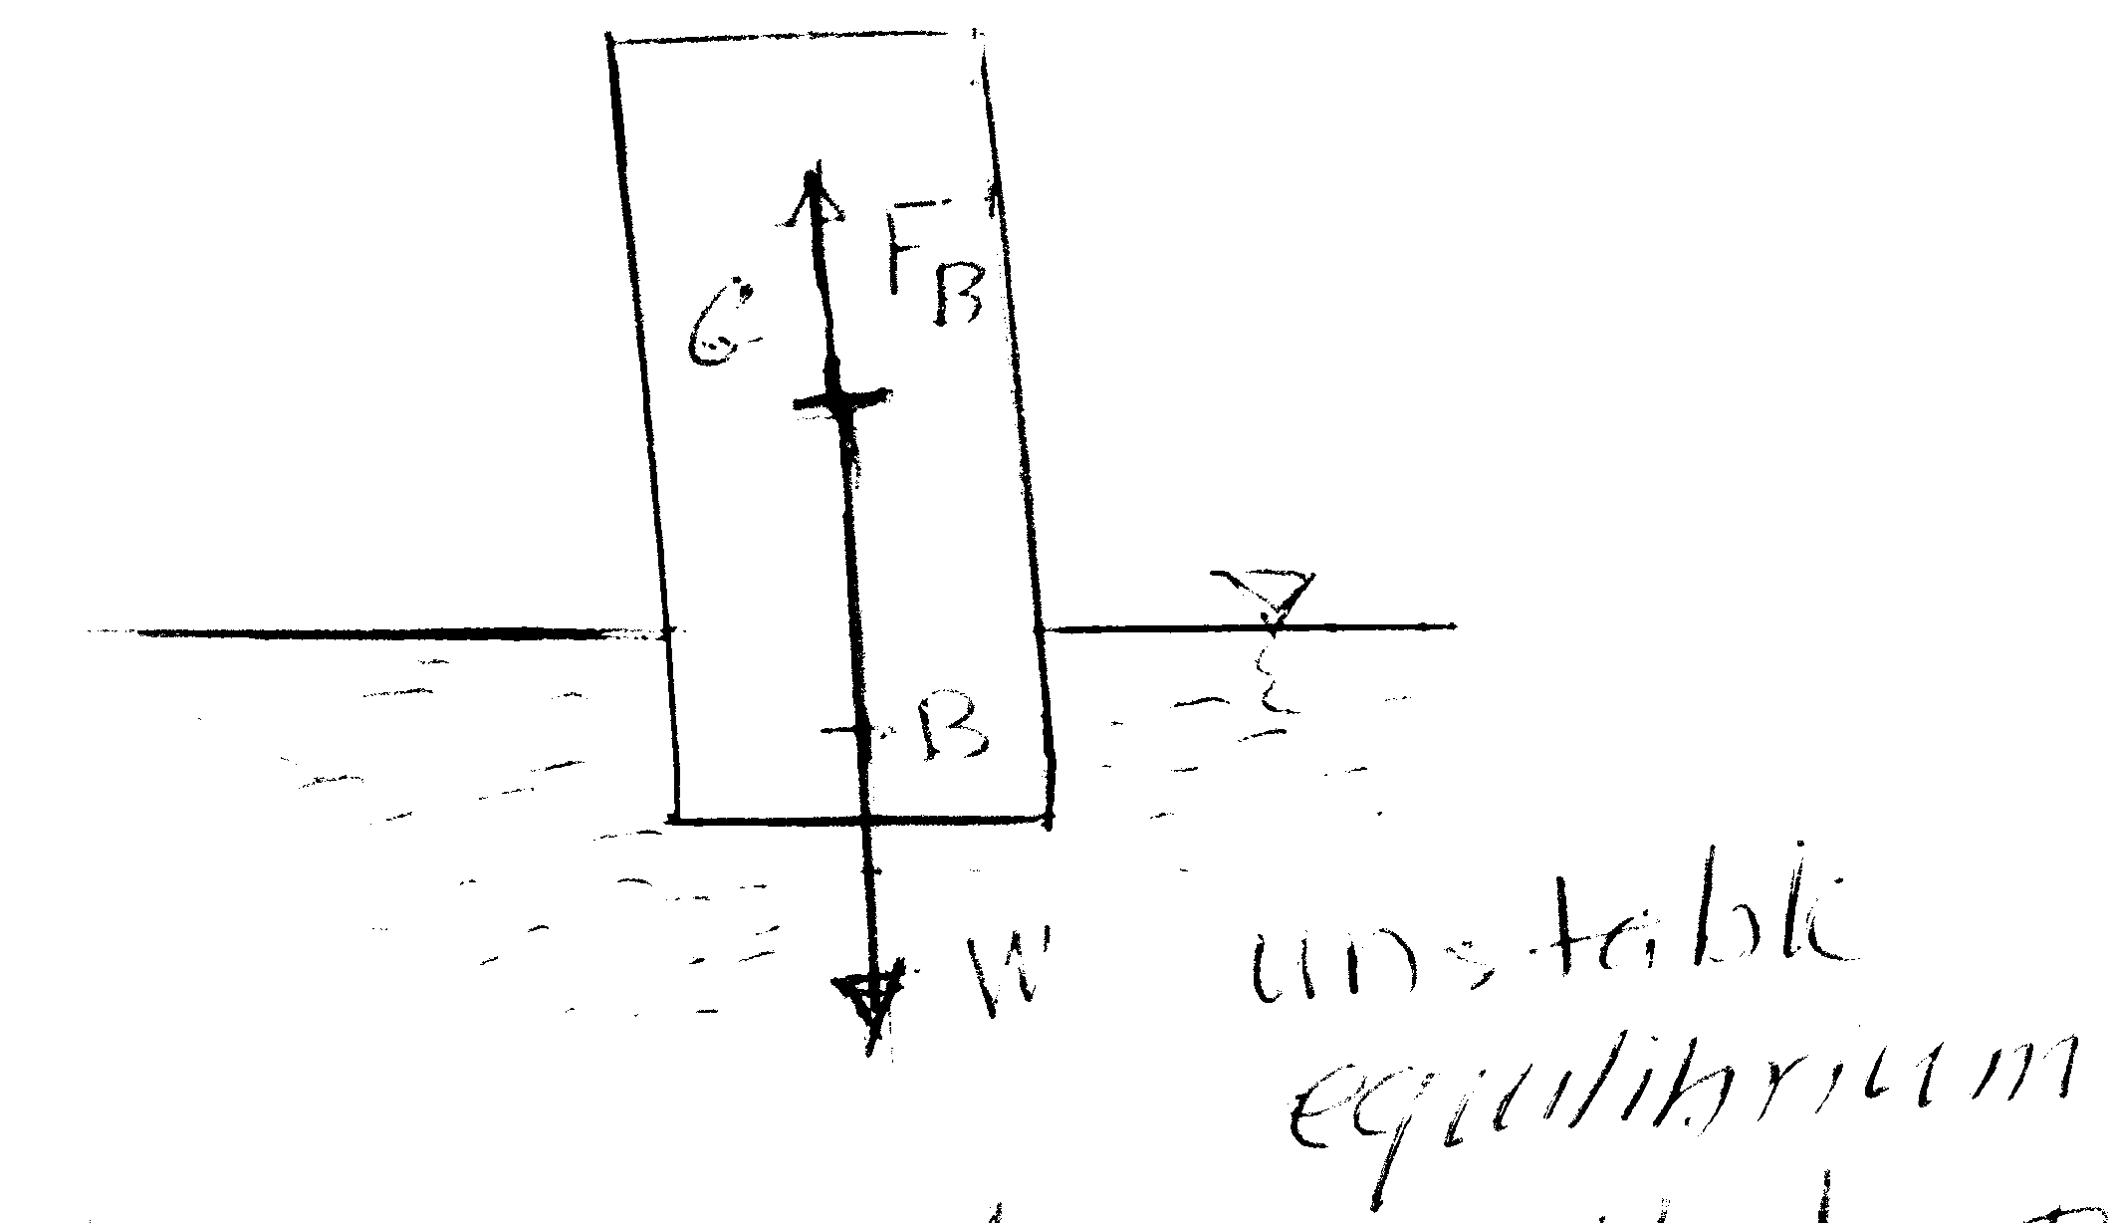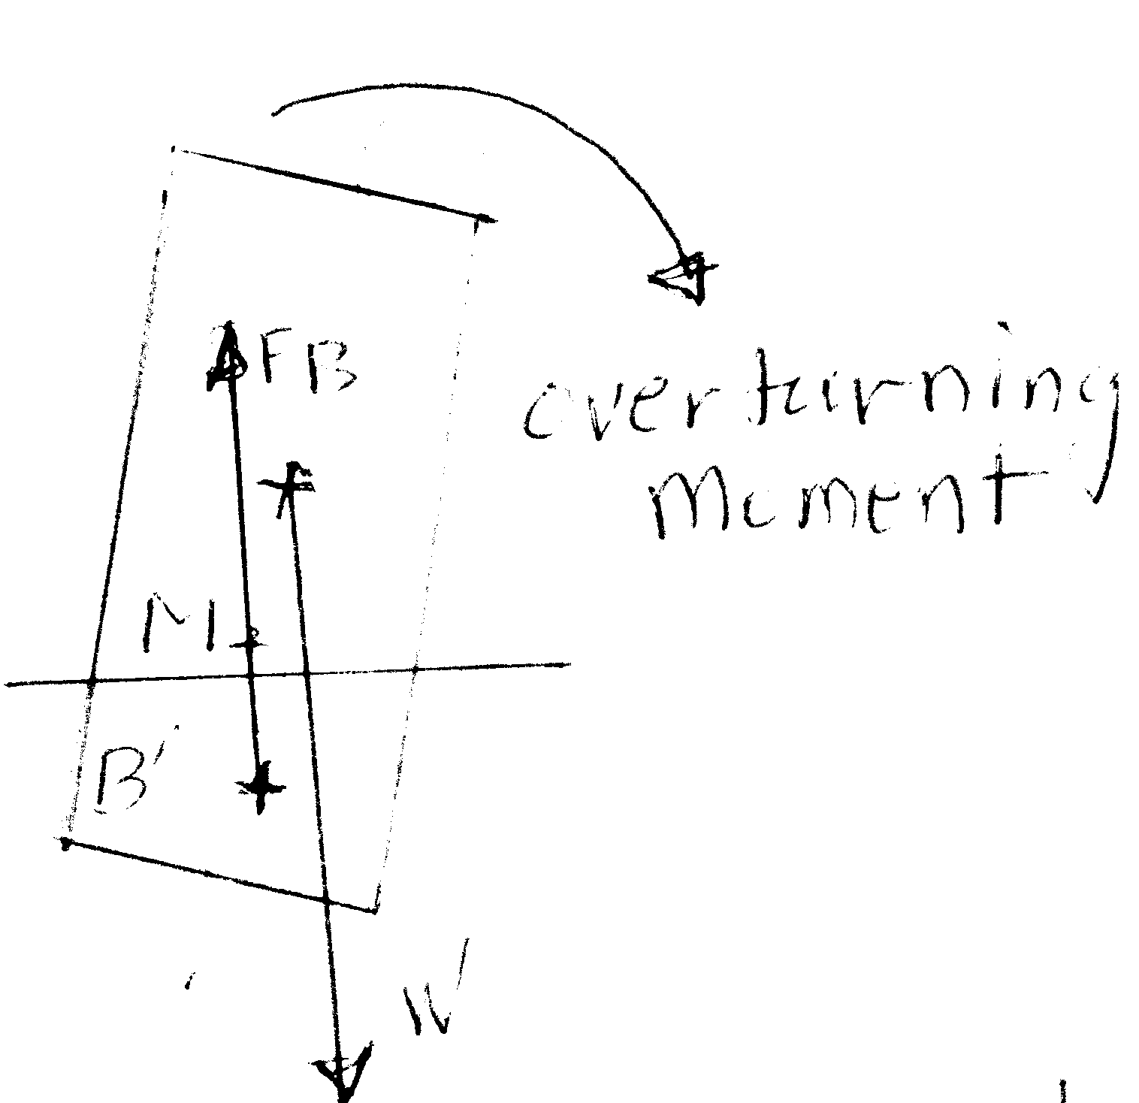
Figure 7-b
Case 2: Unstable equilibrium, when the floating body is tilted to the right, a couple is created due to the deviation between the lines of actions of weight and buoyant force. This moment turn the body over to when the metacenter, M, is below the center of gravity, Figure 7-b

3-c)
c) ) i-
$$\begin{aligned}\vec{V}=(x^{2}−y^{2}+x)i−(\text{2xy}+y)j \\ \vec{V}=\text{ui}+\text{vj}→→u=x^{2}−y^{2}+\text{x,v}=−(\text{2xy}+y) \\ \text{the acceleration \{}\vec{a}\end{aligned}=a_{x}i+a_{y}ja_{x}=\frac{∂u}{∂t}+u\frac{∂u}{∂x}+v\frac{∂u}{∂y}→→a_{x}=(x^{2}−y^{2}+x)(\text{2x}+1)+−(\text{2xy}+y)(\text{-2y})={\text{2x}}^{3}+{\text{2xy}}^{2}+x+3x^{2}+y^{2}a_{y}=\frac{∂v}{∂t}+u\frac{∂v}{∂x}+v\frac{∂v}{∂y}→→a_{y}=(x^{2}−y^{2}+x)(\text{-2y})+−(\text{2xy}+y)(\text{-2x-1}))={\text{2y}}^{3}+{\text{2yx}}^{2}+2\text{xy}+ya_{x}=\text{18},a_{y}=\text{26}→\vec{a}=\text{18}i+\text{26}j$$
ii) The flow will represent a physical flow if $\frac{∂u}{∂x}+\frac{∂v}{∂y}=0$, for this flow we have $\frac{∂u}{∂x}+\frac{∂v}{∂y}$$=\text{2x}+1−(\text{2x}+1)=0$ $∴$The flow is a physical flow.

iii) $u=x^{2}−y^{2}+x=\frac{∂ψ}{∂y}→ψ=x^{2}y−\frac{y^{3}}{3}+\text{xy}+f(x)$
$$\begin{aligned}v=−\text{2xy-y}=−\frac{∂ψ}{∂x}→ψ=x^{2}y+\text{xy}+g(y) \\ ∴ψ=x^{2}y−\frac{y^{3}}{3}+\text{xy}\end{aligned}$$
$$u=x^{2}−y^{2}+x=\frac{∂φ}{∂x}→φ=−y^{2}x+\frac{x^{3}}{3}+\frac{x^{2}}{2}+g(y)$$
$$v=−\text{2xy-y}=\frac{∂φ}{∂y}→φ=−{\text{xy}}^{2}−\frac{y^{2}}{2}+f(x)$$
$φ=−y^{2}x+\frac{x^{3}}{3}+\frac{x^{2}}{2}+$$−\frac{y^{2}}{2}$
iv) The vorticity is given by : $\frac{∂v}{∂x}−\frac{∂u}{∂y}=−\text{2y}+\text{2y}=0$
4-a)i)
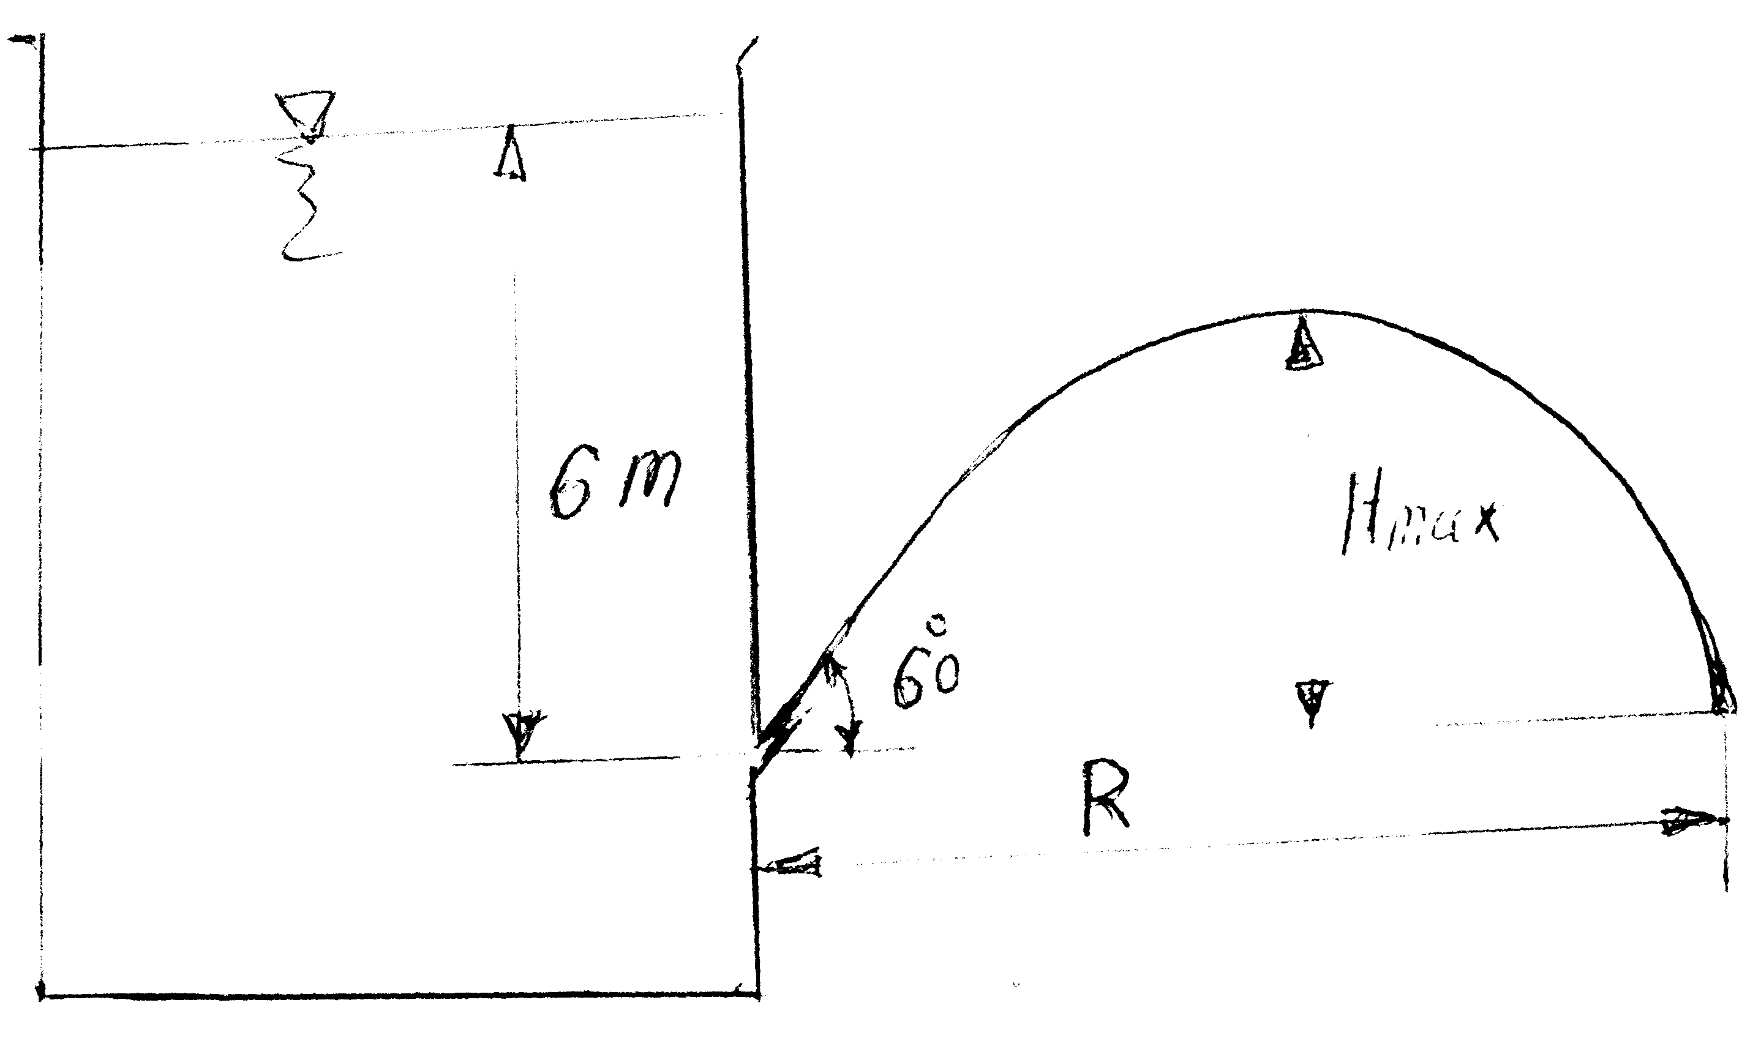
Figure 7
The maximum height H_{max} is given from the relation;
H_{max} = H sin²θ = 6.0x0.25 = 1.5 m;
The range R is given by the equation: $R=\text{2Hsin2θ}→R=2×6×{\text{sin60}}^{∘}$
$$R=6\sqrt{3}=\text{10}\text{.}\text{392m}$$
ii) The time to empty the tank is calculated as follows:
$$\begin{aligned}{\text{-A}}_{T}\frac{\text{dh}}{\text{dt}}=C_{d}A_{o}\sqrt{\text{2gh}}→\text{dt}=−\frac{A_{T}}{C_{d}A_{o}\sqrt{\text{2g}}}\frac{\text{dh}}{\sqrt{h}} \\ t=−\frac{A_{T}}{C_{d}A_{o}\sqrt{\text{2g}}}\int_{6}^{0}{\frac{\text{dh}}{\sqrt{h}}=}−\frac{{\text{2A}}_{T}\sqrt{h}}{C_{d}A_{o}\sqrt{\text{2g}}}↕_{6}^{0}→t=1\text{382}\text{.}5\text{sec}\end{aligned}$$
4-b)
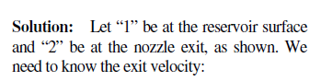
As shown in Figure 8
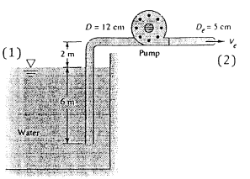
Figure 8
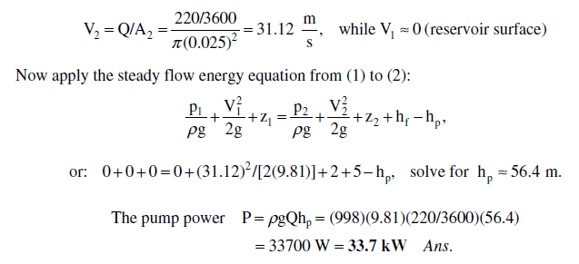
5-a)
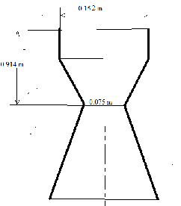
Figure 9
From the question:
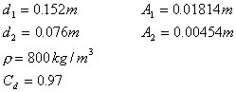
Apply Bernoulli:
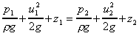
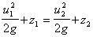
By continuity:
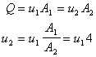
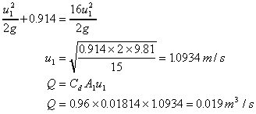
ii)
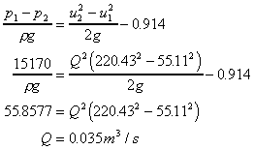
5-b)

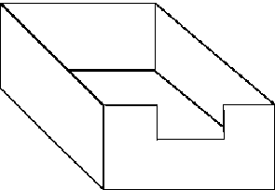
From the question A = 60 000 m², Q = 0.678 h ^{3/2}
Write the equation for the discharge in terms of the surface height change:
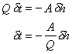Integrating between h₁ and h_{2,} to give the time to change surface level
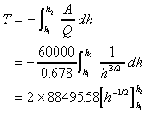
From the question T = 3600 sec and h₁ = 0.6m
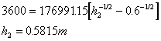
Total depth = 3.4 + 0.58 = 3.98m

