  Benha University | Benha Faculty of Engineering
 | Mechanical Engineering Dept. |  | 1rd Year
 | M1171 | Basics of manufacturing and workshops | Final Exam, January, 2016  تخلفات
 | Examiner:  Assistant Professor. Saleh Kaytbay |  |  | Time: 3 hours
Answer the following questions, Use the drawing whenever possible

First question (20 mark)
- Explain the Expanded Polystyrene Process, steps , Advantages and Disadvantages
- What is the Directional Solidification and how can achieving it?
- What properties determine the quality of a sand mold for sand casting?
- The total solidification times of three casting shapes are to be compared: (1) a sphere with diameter =10 cm, (2) a cylinder with diameter and length both = 10 cm, and (3) a cube with each side = 10 cm. The same casting alloy is used in the three cases. (a) Determine the relative solidification times for each geometry. (b) Based on the results of part (a), which geometric element would make the best riser? (c) If the mold constant = 3.5 min/cm2in Chvorinov's rule, compute the total solidification time for each casting.
Second question(20 mark)
- Identify some of the important advantages and some of the limitations of casting?
- Draw the Steps in the production sequence in sand casting
- Explain the Shell Molding, steps , Advantages and Disadvantages
- Give the name of each number
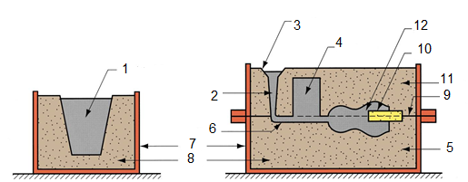

Third question(20 mark)
- Classify the types of joints and welding positions?
- Explain the Functions of flux?
- What are the several zones in a fusion weld?
اكمل فى الصفحة التالية
- A heat source transfers 3000W to the surface of a metal part. The heat impinges the surface in a circular area, with intensities varying inside the circle. The distribution is as follows: 70% of the power is transferred within a circle of diameter =5mm, and 90% is transferred within a concentric circle of diameter = 12 mm. What are the power densities in (a) the 5-mm diameter inner circle and (b) the 12-mm-diameter ring that lies around the inner circle?

Fourth question(15 mark)
Any of the following statements is false and why?
اي من هذه الجمل خطأ ولماذا؟
- Sand casting is a permanent mold casting.
- In sand casting, cores are generally made of metal.
- The upper half of a sand-casting mold is called drag.
- In foundry work, a runner is a vertical channel into which molten metal is poured into the mold.
- Turbulence during pouring of the molten metal is undesirable because it increases the mold filling time
- Total solidification time is a time between solidification and cooling to room temperature
- In a sand-casting mold, the V/A ratio of the riser should be equal to V/A ratio of the casting itself
- A pure metal solidifies at a temperature range.
- Soldering is a joining method using a high melting point
- Gas-tungsten arc welding is consumable electrode.

مع اطيب التمنيات بالتوفيق
ا.م.د/ صالح قيتباى

