  Benha University | Benha Faculty of Engineering
 | Mechanical Engineering Dept. |  | 3rd Year
 | M1271 | Manufacturing Technology  تخلفات | Final Exam ,Jan 2016
 | Examiner: | Ass. Prof. Saleh Kaytbay |  | Time: 3 hours
Answer the following questions, Use the drawing whenever possible
First question (24 mark)
- Define the riser, types and Sketch the difference between top risers and side risers?
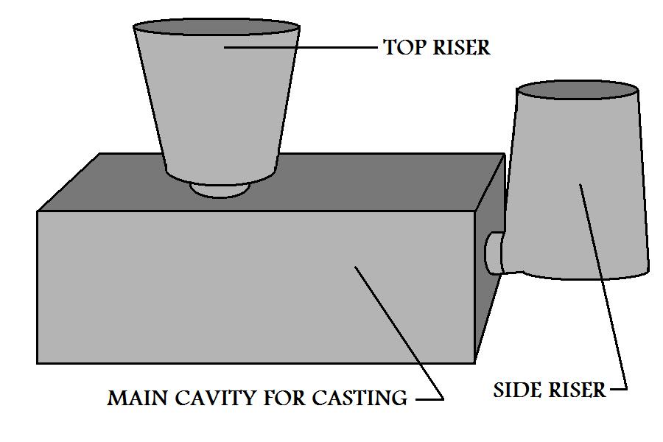
Risers are reservoirs of molten material, to compensate for shrinkage as the casting solidifies.
- There are different classifications for risers.
Top Risers: feed the metal casting from the top.
Side Risers: feed the metal casting from the side.
Blind Risers: completely contained within the mold.
Open Risers: open at the top to the outside environment.

- What are the reasons that gases are absorbed into the melt during casting, how can prevent the Gas Defects?
- There are various reasons that gases are absorbed.
  - Turbulent flow of the casting, trap gas from the air.
  - From material or atmosphere in the crucible.
  - From the reaction between the molten metal and the mold material.
Prevention of Gas Defects when Manufacturing a Part by Casting:
- a proper venting system in the mold.
- Reduce the amount of turbulence
- Removal of slag
- Flushing a metal melt with inert gas.
- Pouring the casting in a vacuum.

- Define the sand and what is advantage?
Define Sand: Product of the disintegration of rocks over long periods of time.
Most sand casting operations use silica sand (SiO2).
advantage
- Sand Casting is the most widely used
- Almost all metal casting materials can be sand cast
- Range in size from very small to extremely large, Examples, engine blocks, machine tool bases, cylinder heads, pump housings, and valves, just to name a few.
- Inexpensive, very resistant to elevated temperatures, used for metals with high melting temperatures such as steels, nickel, and titanium,
- Usually sand used to manufacture a mold for the casting process is held together by a mixture of water and clay.89% sand, 4% water, 7% clay.

- Molten metal can be poured into the pouring cup of a sand mold at a steady rate of 1000 cm³/s. The molten metal overflows the pouring cup and flows into the downsprue. The cross section of the sprue is round, with a diameter at the top = 3.4 cm. If the sprue is 25 cm long, determine the proper diameter at its base so as to maintain the same volume flow rate
Solution: Velocity at base v = (2gh)0.5 = (2 x 981 x 25)0.5 = 221.5 cm/s
Assuming volumetric continuity, area at base A = (1000 cm/s)/(221.5 cm/s) = 4.51 cm2
Area of sprue A = πD2/4; rearranging, D2 = 4A/π = 4(4.51)/π = 5.74 cm2 D = 2.39 cm

.Second question(26 mark)
- What is the process, Properties and Considerations of Manufacturing by Plaster Mold Casting?
The Process
- mixed with water
- mixed with various additives such as talc and silica flour , to control the setting time and improve its strength.
- poured over the casting pattern, from plastic or metal.
- 20 minutes before it sets enough to remove the pattern.
- baked for several hours to remove the moisture and become hard enough to pour the casting.
- two halves of the mold are then assembled for casting
Properties and Considerations of Plaster Mold Casting
- water should be left in the mold, Too much moisture in the mold can cause casting defects, but if the mold is two dehydrated it will lack adequate strength.
- The fluid plaster slurry flows readily over the pattern, making an impression of great detail and surface finish.
- low thermal conductivity of the mold will solidify slowly creating more uniform grain structure
- plaster mold enable the process to manufacture parts with excellent surface finish, thin sections, and produces high geometric accuracy.
- plaster mold will not withstand temperature above 1200C, used to aluminum, magnesium, zinc, and copper based alloys.
- production rates are relatively slow due to the long preparation time for the mold.
- The plaster mold is not permeable which severely limits the escape of gases from the casting

- Define the following: Flow Stress, engineering stress and strain, strain rate, Blooms
- The flow stress is the instantaneous value of the force necessary to continue the yielding and flow of the work material at any point during the process.
- The engineering stress is defined as the force divided by the original area 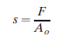
- The engineering strain is defined relative to the original area and length
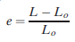
- The strain rate is directly related to the speed at which deformation is occurring, it is depend on temperatures.
- A bloom has a square cross section 150 mm 150 mm or larger.

- In casting experiments performed using a steel alloy (ρ = 7.8 g/cm3) and type of sand mold, it took 155 sec for a cylindrical shaped casting to solidify. The cylindrical was 30 mm diameter and weighs 4.5kg. (a) Determine the dimensions of casting. (b) Determine the value of the mold constant in Chvorinov's rule. (C) If the same alloy and mold type were used, find the total solidification time for a cube casting in which the cube was 50 mm on a side
Solution: (a) Volume V = (50)3 = 125,000 mm3
Area A = 6 x (50)2 = 15,000 mm2
(V/A) = 125,000/15,000 = 8.333 mm
Cm = TTS /(V/A)2 = 155/(8.333)2 = 2.232 s/mm2
(b) Cylindrical casting with D = 30 mm and L = 50 mm.
Volume V = πD2L/4 = π(30)2(50)/4 = 35,343 mm3
Area A = 2πD2/4 + πDL = π(30)2/2 + π(30)(50) = 6126 mm2
V/A = 35,343/6126 = 5.77
TTS = 2.232 (5.77)2 = 74.3 s = 1.24 min

- A cylindrical riser must be designed for a sand-casting mold. The casting itself is a steel rectangular plate with dimensions 7:5 cm x 12:5 cm x 2:0 cm. Previous observations have indicated that the total solidification time (T_{TS}) for this casting = 1.6 min. The cylinder for the riser will have a diameter-to-height ratio=1.0. Determine the dimensions of the riser so that it’s T_{TS} = 2.0 min
Solution: Casting volume V = tL2 = 0.75(10.0)2 = 75 in3
Casting area A = 2L2 + 4Lt = 2(10.0)2 + 4(10.0)(0.75) = 230.0 in2
V/A = 75/230 = 0.3261 Casting TTS = 16(0.3261)2 = 1.70 min
Riser TTS = 1.30(1.70) = 2.21 min
Riser volume V = πD2H/4 = 0.25πD2(1.25D) = 0.3125πD3
Riser area A = 2πD2/4 + πDH = 0.5πD2 + 1.25πD2 = 1.75πD2
V/A = 0.3125πD3/1.75πD2 = 0.1786D
Riser TTS = 16.0(0.1786D)2 = 16.0(0.03189)D2 = 0.5102D2 = 2.21 min
D2 = 2.21/0.5102 = 4.3316
D = (4.3316)0.5 = 2.081 in
H = 1.25(2.081) = 2.602 in.

Third question(25 mark)
- Explain Closed-die design in forging
General rules of closed-die design
- The die set should be designed for smooth metal flow – symmetry dies (spherical or block like) are the easier than thin and long section.
- Shape changes in section are to be avoided.
- Dies should be designed for the minimum flash to do the job.
- Dies must be drafted to facilitate removal of the finished piece.
- Draft allowance is approximately 3-5º outside and 7-10º inside.

- Compare between the direct and indirect extrusion
- Direct versus Indirect Extrusion Direct extrusion (also called forward extrusion).  - A metal billet is loaded into a container, and a ram compresses the material, forcing it to flow through one or more openings in a die at the opposite end of the container.  - As the ram approaches the die, a small portion of the billet remains that cannot be forced through the die opening.  - This extra portion, called the butt, is separated from the product by cutting it just beyond the exit of the die.  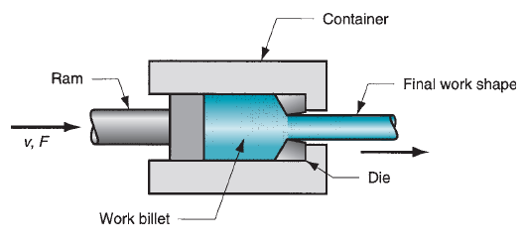 | - In indirect extrusion, also called backward extrusion and reverse extrusion, the die is mounted to the ram rather than at the opposite end of the container.  - As the ram penetrates into the work, the metal is forced to flow through the clearance in a direction opposite to the motion of the ram.  - Since the billet is not forced to move relative to the container, there is no friction at the container walls, and the ram force is therefore lower than in direct extrusion.  - Limitations of indirect extrusion are imposed by the lower rigidity of the hollow ram and the difficulty in supporting the extruded product as it exits the die.  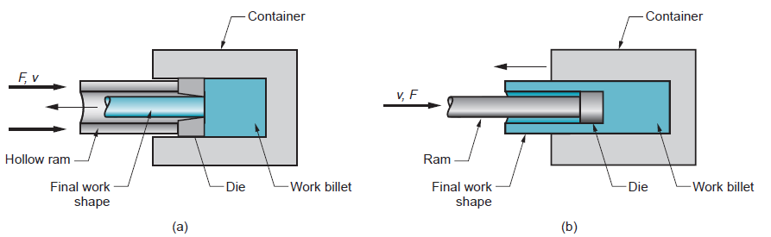

- A 300-mm-wide strip 25-mm thick is fed through a rolling mill with two powered rolls each of radius =250 mm. The work thickness is to be reduced to 22 mm in one pass at a roll speed of 50 rev/min. The work material has a
flow curve defined by K = 275 MPa and n = 0.15, and the coefficient of friction between the rolls and the work is assumed to be 0.12. Determine if the friction is sufficient to permit the rolling operation to be accomplished. If so, calculate the roll force, torque, and horsepower. Contact length L = (250 x 5).5 = 35.35 mm

- A cylindrical billet that is 100 mm long and 50 mm in diameter is reduced by indirect (backward) extrusion to a 20 mm diameter. The die angle is 90°. The Johnson equation has a = 0.8 and b = 1.4, and the flow curve for the work metal has a strength coefficient of 800 MPa and strain hardening exponent of 0.13. Determine (a) extrusion ratio, (b) true strain (homogeneous deformation), (c) extrusion strain, (d) ram pressure, and (e) ram force.

Solution: (a) rx = Ao/Af = Do2/Df2 = (50)2/(20)2 = 6.25
(b) ε = ln rx = ln 6.25 = 1.833
(c) εx = a + b ln rx = 0.8 + 1.4(1.833) = 3.366
(d) Y f = 800(1.833)0.13/1.13 = 766.0 MPa
p = 766.0(3.366) = 2578 MPa
(e) Ao = πDo2/4 = π(50)2/4 = 1963.5 mm2
F = 2578(1963.5) = 5,062,000 N

مع اطيب التمنيات بالتوفيق - ا.م.د/ صالح قيتباى

