
Benha University
Benha C0llegebof Engineering

Department of Mechanical Eng.
Subject : Gas Dynamics

Model Answer of The Final Exam Date: Jan./16/ 2016
Elaborated by: Dr. Mohamed Elsharnoby
نموذج اجابة مادة ديناميكا الموائع و الغازات م 401
تاريخ الامتحان السبت 16 يناير 2016
1-a) .The equation relating the relative change in area with the relative change in velocity is given by:
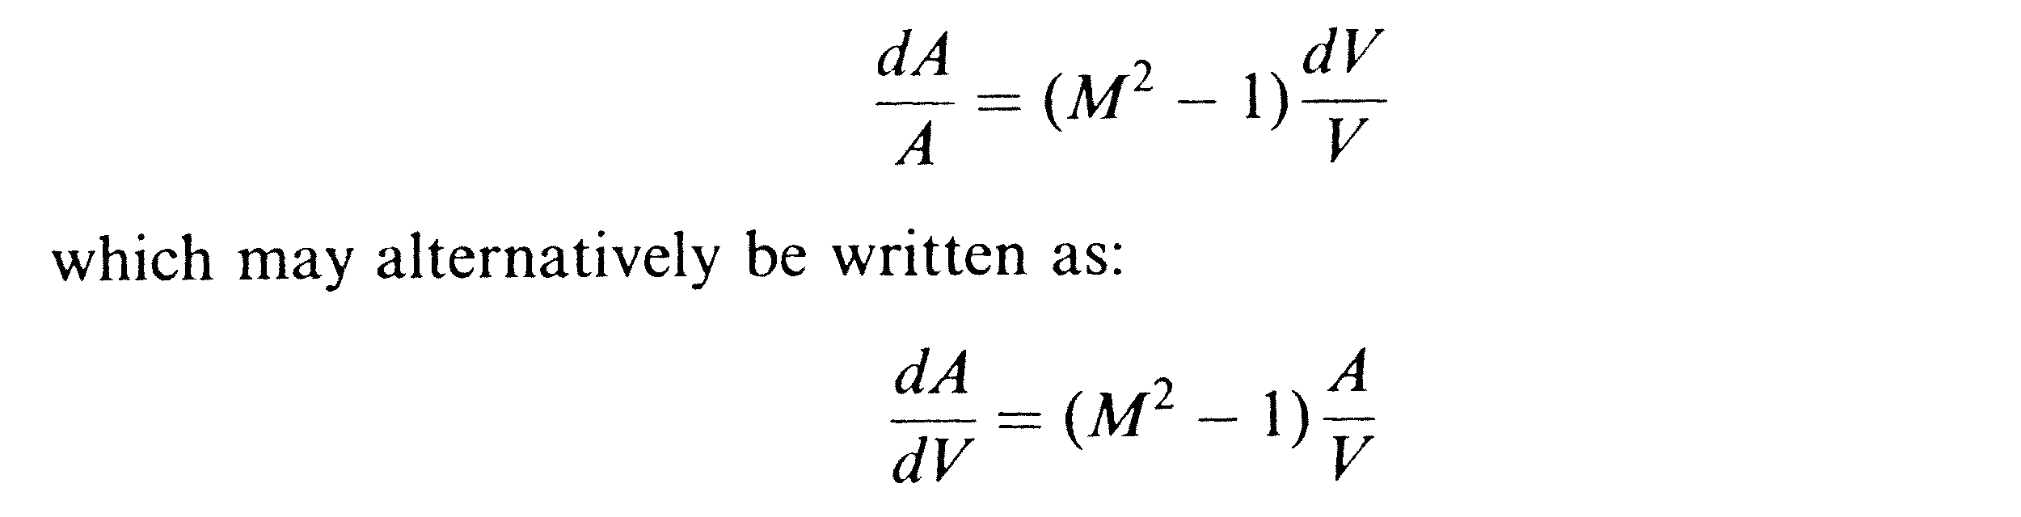 b)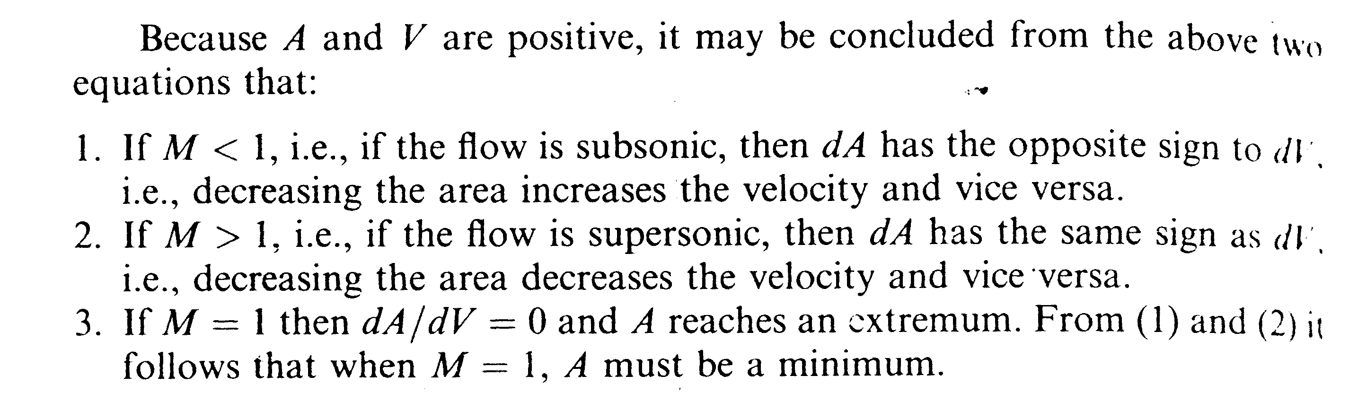

1-c

2-a) Rayleigh flow is one-dimensional frictionless flow in constant area duct with heat addition and removal
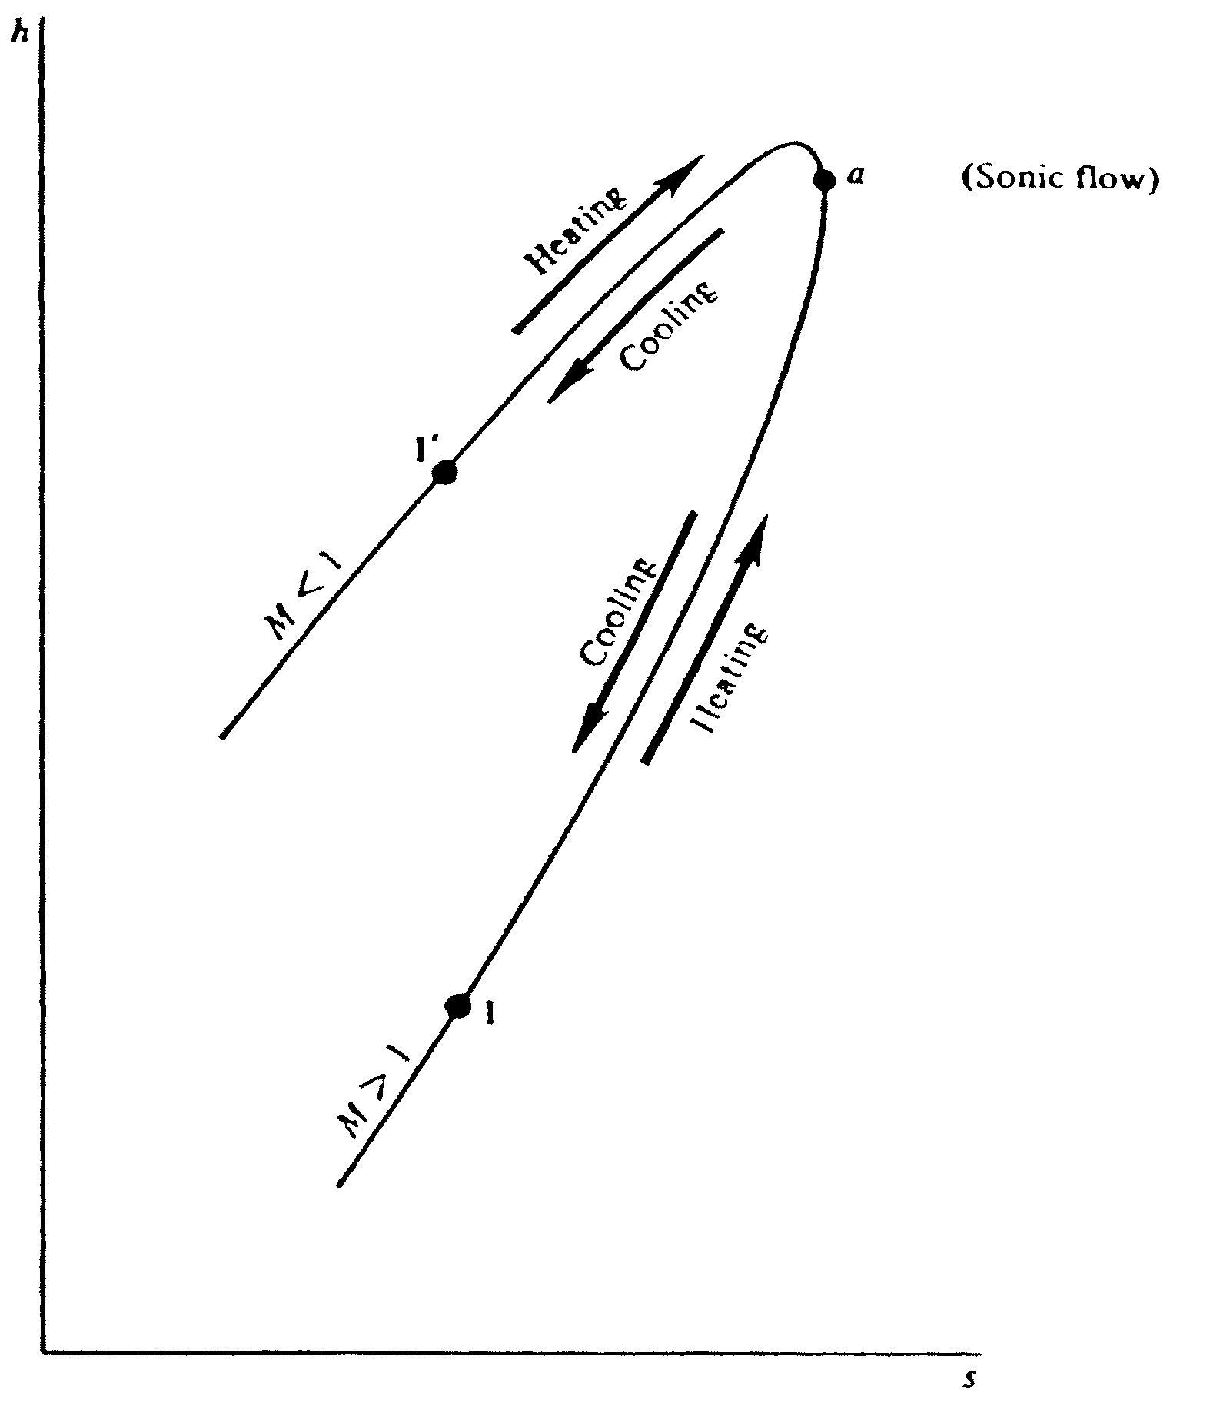.
Figure 2. Rayleigh curve

Heating always pushes the flow towards the sonic conditions and vice versa. This is clear on the Rayleigh curve shown above In detail we can conclude the following:

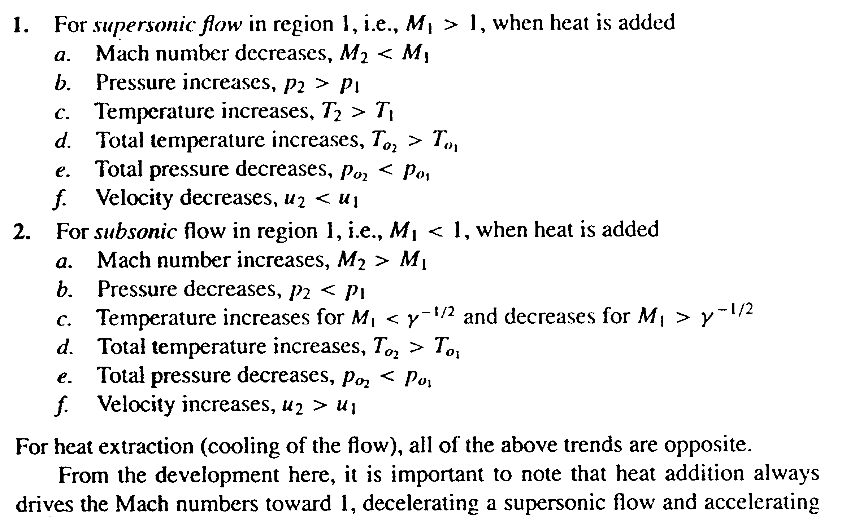
2-b

2-c) The situation under consideration is shown in Fig.3

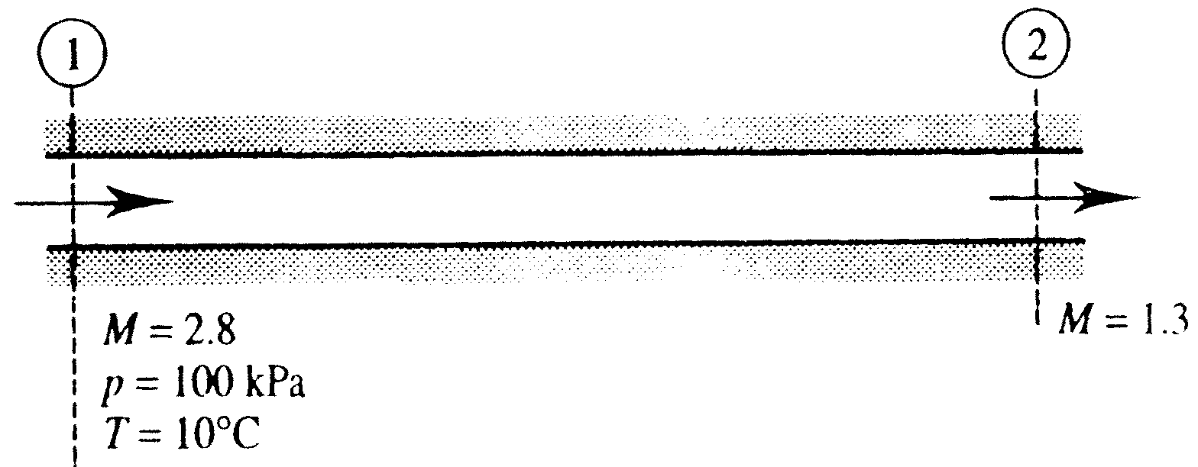
Fig.3
Now for Mach number 2.8 using the relation.
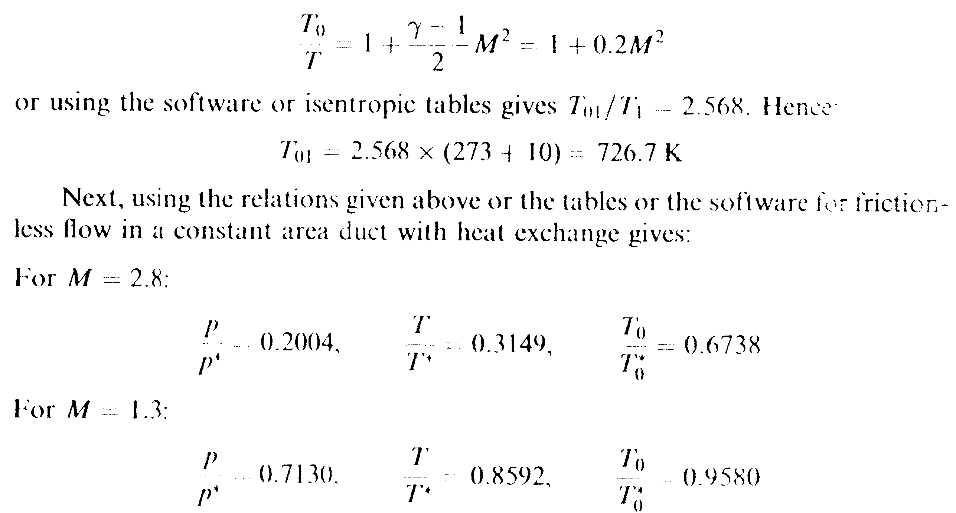

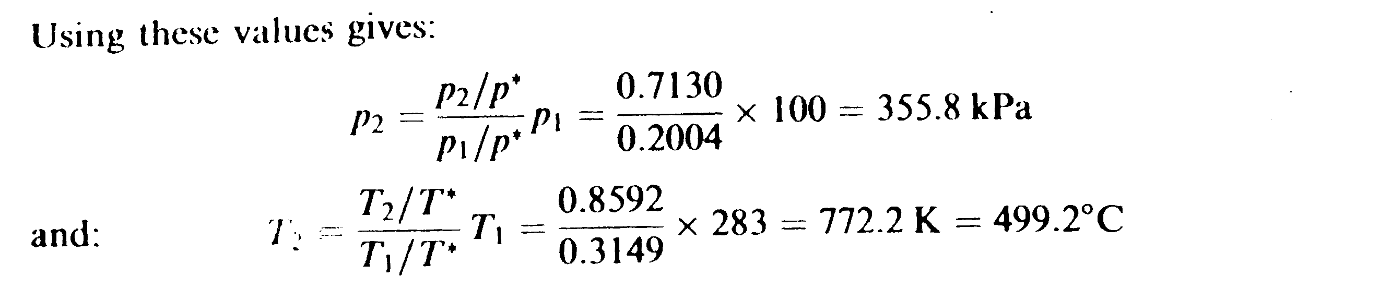 Therefore, the pressure and temperature of the air at the outlet to the duct are 355.8 kPa and 499.2ºC respectively.
When the maximum amount of heat is transferred to the flow, the Mach number at exit becomes one, then the total temperature$T_{\text{02}}$ will equal $T_{o}^{}$.Hence in this case:
$$T_{\text{02}}=\frac{T_{\text{01}}}{T_{\text{01}}/T_{0}^{}}=\frac{\text{726}\text{.}7}{0\text{.}\text{6738}}=\text{1078}\text{.}\text{5K}$$
but q = Cp($T_{\text{02}}$-$T_{\text{01}}$) = 1.007(1078.5-726.7)=354.3 kJ/kg
it having been assumed that Cp = 1.007 kJ/kg.
Also when the maximum amount of heat has been transferred:
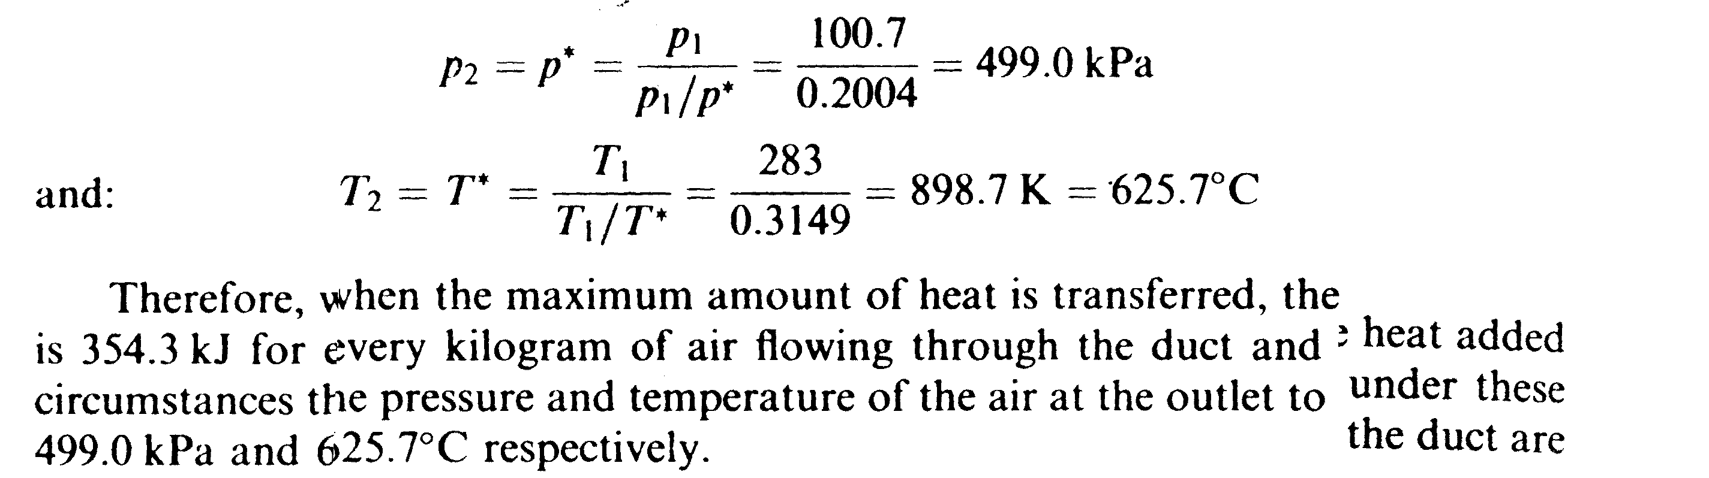

3-a) Fanno flow is the one-dimensional adiabatic flow in a constant area duct with friction effect. The mach number variation for supersonic inlet flow with the duct length is shown below. When L = L* Mach number reaches unity at exit ; but when L increases ther exist a normal shock wave in the duct which moves forward as L increases more and more; this is shown in Fig.4.
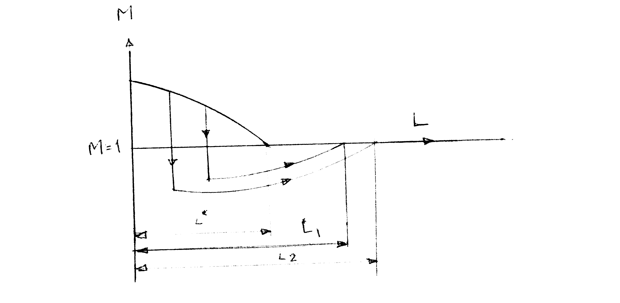
Figure 4
b)
The situation under consideration is shown in Fig.3

Fig.3

4-a) The assumptions for derivation of the linearzed velocity potential are :
i) The perturbations are very small $\frac{u}{U_{∞}}\text{<<}\text{1,}\frac{v}{U_{∞}}\text{<<}\text{1,}\frac{w}{U_{∞}}\text{<<}1$.
ii) Ranges of Mach number are ,0<$M_{∞}$<0.8, $M_{∞}$ >1.2
iii) Flow is not hypersonic $M_{∞}$<5
These assumptions fail at leading edge where assumption (i) is invalid, for transonic flow for which .8<$M_{∞}$<1.2 ( assumption (ii) is invalid, and for hypersonic flow for which $M_{∞}$>5.

b)The lower critical Mach number ($M_{∞\text{cr}1}$) is the upstream ( non-disturbed ) flow Mach number at which the maximum local velocity on the airfoil reaches the speed of sound at one point only. This point is called the minimum pressure point or the point of maximum suction.
Evaluation the lower critical Mach number for airfoil with Cp_{imin}=-0.7 .
The characteristic Mach number at point of maximum suction when the airfoil is traveling at $M_{∞\text{cr}1}$is equal 1.0 i.e $λ_{c}$= 1.0, from Cristianowich diagram $\text{λi}$= 0.7577
From the equation $\text{λi}$= $λ∞i$ $\sqrt{{1−\text{Cp}}_{i}}$ , $λ∞i$= $\frac{0\text{.}\text{7577}}{\sqrt{1−(−0\text{.}7)}}$ = 0.581
From Cristianowich diagram the characteristic Mach number for the upstream ( non-disturbed ) flow is $λ∞c$= 0.638 for which the $M_{∞\text{cr}1}$ = 0.8118.
5-a) It is known that ${\text{sin}}^{\text{-1}}1/M_{∞}<β<\text{π/2}$ . Consequently $\text{19}\text{.}{\text{47}}^{∘}<β<{90}^{∘}$.
b) The situation is shown below in Fig.7
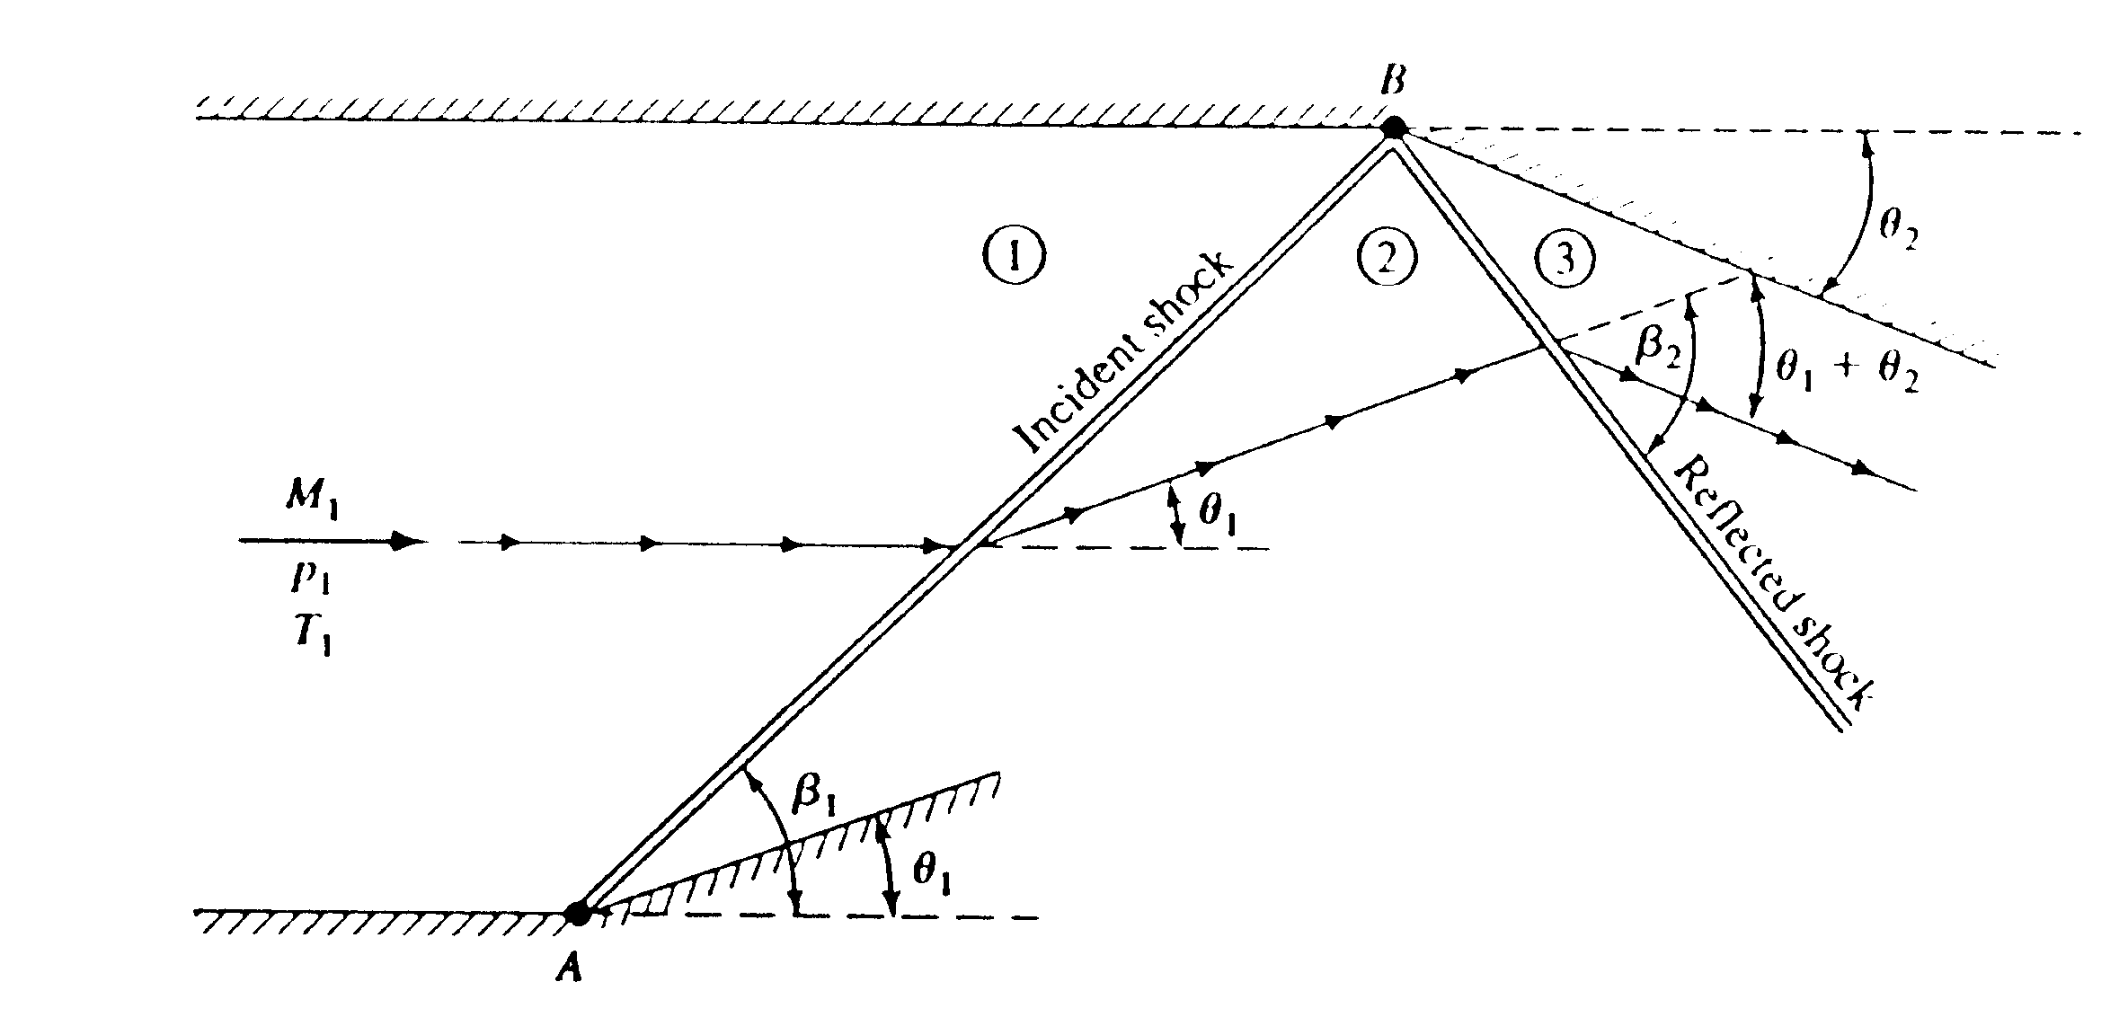
Figure 7
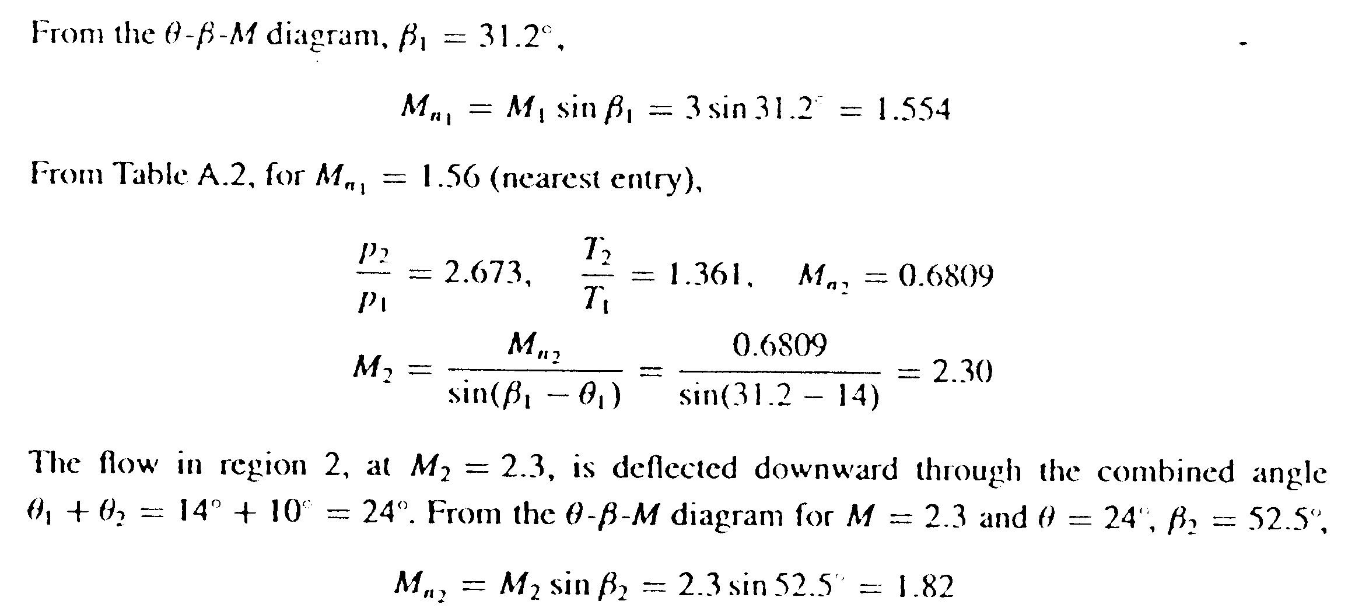

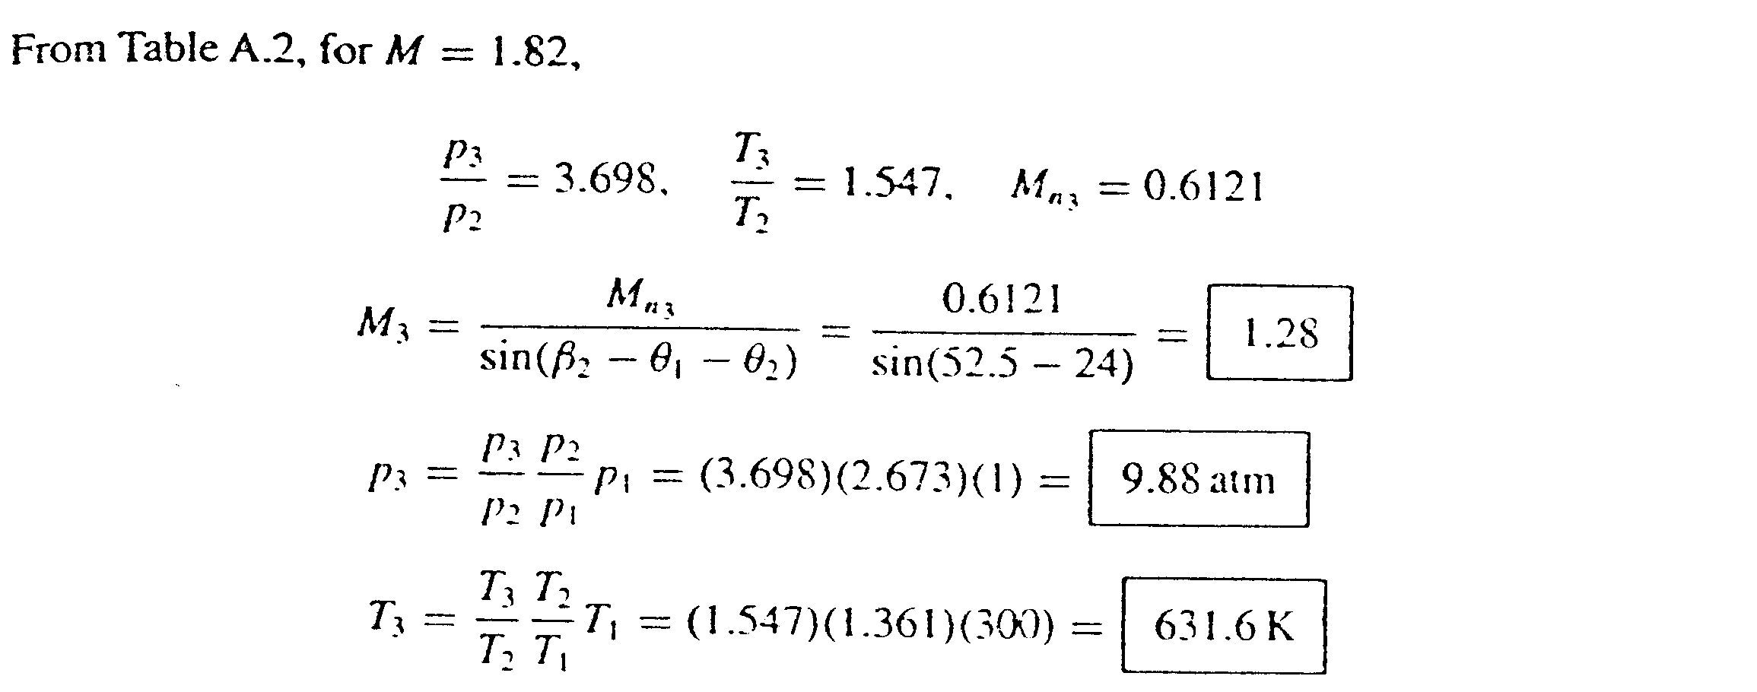
The process on the pressure deflection diagram is shown below in Figure 8 where the pressure change from p₁ to p₂ an finally to p₃ at point 3.
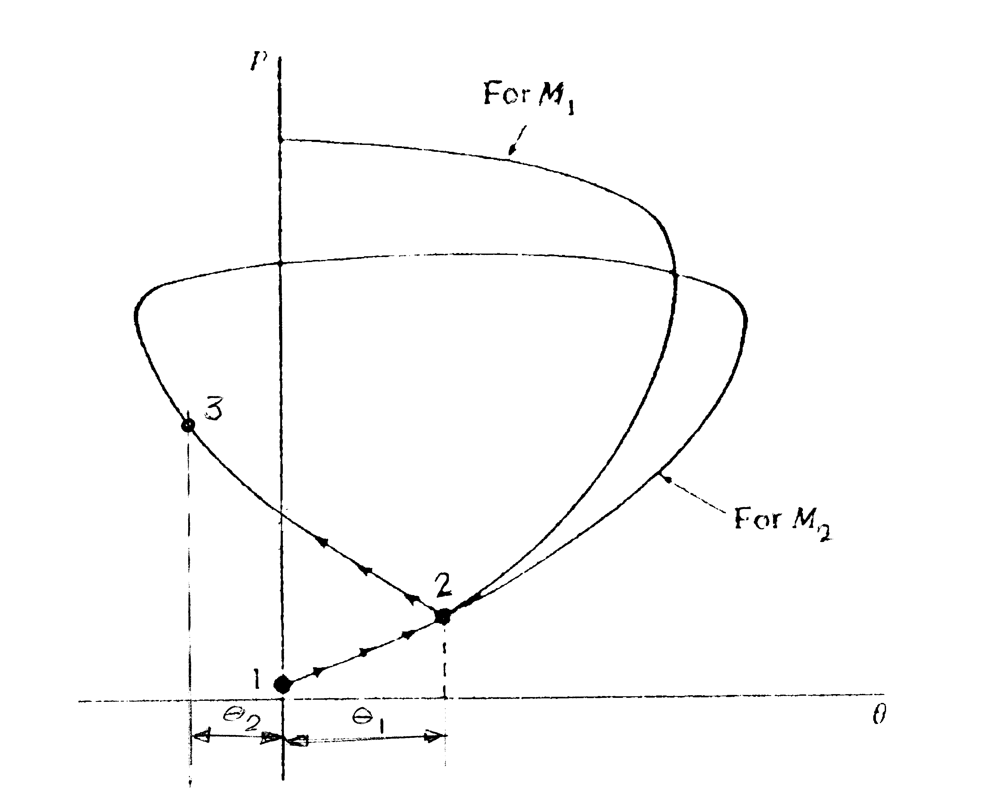
Figure 8 (reflection on pressure deflection diagram)
From $θ−β−M$ curves, for $M_{3}$= 1.28 $θ_{\text{max}}$ = 6.5 degrees.

