
Benha University
College of Engineering at Banha
Mechanical Eng. Dept. 4th Year Mechanics
Subject :Automatic Control January/2015
Model Answer of the Final Corrective Examination
Elaborated by: Dr. Mohamed Elsharnoby
نموذج اجابة
المادة : التحكم الآلى م 482
أستاذ المادة : د. محمد عبد اللطيف الشرنوبى

1-a) The signal flow graph of the sysytem shown in Figure 1. List all loops, , and use Masson rule to find the transfer function of the given system.
Figure 1
Loops are L₁ = - 5/s , L₂ = - 2/s , L₃ = - 3/s
Paths are M₁= -20/s, M₂= -10/s, , M₃= 30/s

∆ = 1 – (L₁ + L₂ + L₃ ) + ( L₁L₂+ L₁L₃ +L₂L₃ ) - (L₁L₂L₃ )
∆ = 1 + 10/s +31/s² +30/s³
∆₁ = 1 + 5/s +6/s²
∆₂ = 1 + 8/s +15/s²
∆₃ = 1 + 7/s +10/s²

$$\text{TF }=\frac{M_{1}Δ+M_{2}Δ+M_{3}Δ}{Δ}=\frac{\frac{\text{30}}{s^{2}}+\frac{\text{30}}{s^{3}}}{{\text{1 + 10/s +31/s}}^{2}{\text{ +30/s}}^{3}}=\frac{\text{30}(s+1)}{s^{3}+\text{10}s^{2}+\text{31}s+\text{30}}$$
ii) For unit step input R(s)=1/s
then Y(s)= $\left\lfloor \frac{\text{30}(s+1)}{s^{3}+\text{10}s^{2}+\text{31}s+\text{30}}\right\rfloor \frac{1}{s}$
The steady state value of Y =$y(∞)=\underset{s→0}{\text{lim}}\text{sY}(s)=1$
The steady state error is 0

1-b)
If the transfer function of a system is given by:
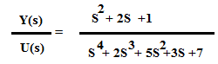
Devide both numenator and denomenator by s⁶
we get $\text{TF}=\frac{\frac{1}{s^{2}}+\frac{2}{s^{3}}+\frac{1}{s^{4}}}{1+\frac{2}{s}+\frac{5}{s^{2}}+\frac{3}{s^{3}}+\frac{7}{s^{4}}}$

i) signal flow graph represents this system
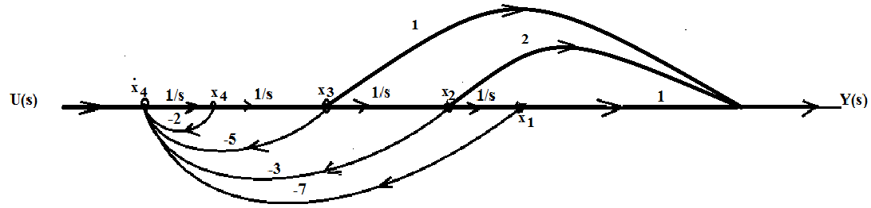
Figure 2

Ii )Deduce the state space representation of the system., iii
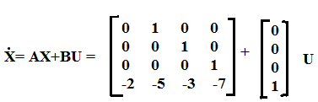
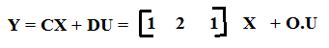

2-a)

2-b) System (a) is type zero with k_{P} =10 . k_{v} =,0 k_{a}=0,
And the steady state errors for unit step, ramp, and acceleration inputs are respectively 1/11, ∞, ∞.
System (b) is type one with k_{P} =∞ . k_{v} =,-2.5 k_{a}=0,
And the steady state errors for unit step, ramp, and acceleration inputs are respectively 0, -0.4, ∞.
System (c) is type one with k_{P} =∞ . k_{v} =,0.4, k_{a}=0,
And the steady state errors for unit step, ramp, and acceleration inputs are respectively 0, 2.5, ∞.

.

3-a) Consider a unity gain feedback control system. The plant transfer function is G(s)=1/(s^2+5s+6). Let the controller be of the form C(s) =K(s+z)/(s+p). Design the controller (ie choose K, z, p>0) so that the closed loop system has poles at
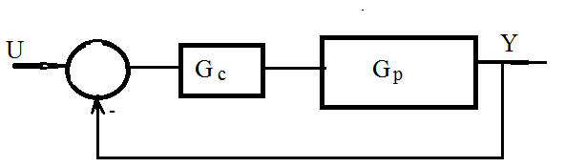
Figure 3
The open loop transfer function is given by $C(s)G(s)=\frac{K(s+z)}{(s+p)(s^{2}+5s+6)}$
The characteristic equation is given by $1+\frac{K(s+z)}{(s+p)(s^{2}+5s+6)}=0$ which is reduced to
(s+p)(s²+5s+6) + K(s+z) = 0
$$s^{3}+(5+p)s^{2}+(6+5p+K)s+(\text{Kz}+6p)=0$$
The function is devisible by (s+1-i)(s+1-i) i.e devisible by s²+2s+2
i.e $s^{3}+(5+p)s^{2}+(6+5p+K)s+(\text{Kz}+6p)$= $(s^{2}+2s+2)(s+a)=0$
$$(s^{2}+2s+2)(s+a)=0$$
$$(s^{2}+2s+2)(s+a)=s^{3}+(2+a)s^{2}+(2+2a)s+2a=0$$
Comparing the coefficients
$$5+p=2+a⇒∵p≻0⇒a≻3$$
$$\begin{aligned}6+5(a−3)+k=2+2a \\ k=\text{11}−3a⇒a≺\frac{\text{11}}{3} \\ \text{kz}+6p=2a→\text{kz}+6(a−3)=2a \\ z(\text{11}−3a)=\text{18}−4a⇒a≺\frac{\text{11}}{3}⇒z≻0\end{aligned}$$
Multiplying the coefficient of s² by 2 and subtract the coefficient of s
$$4−3p−k=2→k+3p=2$$
$$0≺p≺\frac{2}{3},0≺k≺2$$
$\text{kz}=2a−6p⇒2≺\text{kz}≺\frac{\text{22}}{3}$$∴z≻1$
$$∴0≺p≺\frac{2}{3},0≺k≺2,z≻1$$
3-b) For the control system shown in figure 3, sketch the root locus for the following three cases, indicate its direction, where K = 0, where K = ∞, and if they exist, find asymptotes.
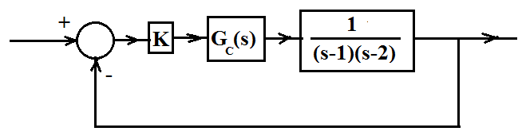
Figure 4

- G_{c}(s) = 1. , (ii) G_{c}(s) = s+1 (PD compensation), (iii)G_{c}(s) =1+1/s (PI compensation).
For the appropriate choice of compensator, use root locus and Routh Hurwitz techniques to find the range of K for
an under damped response
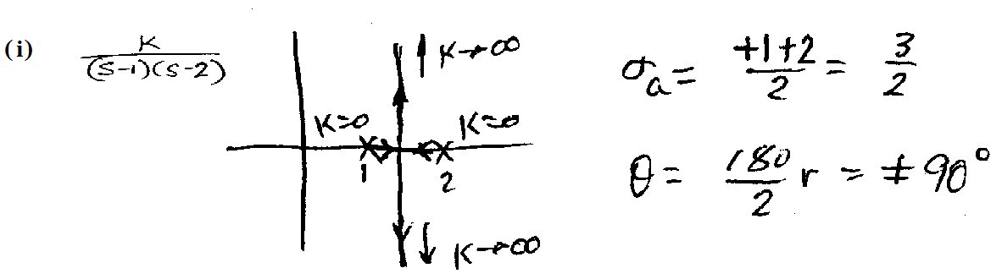.
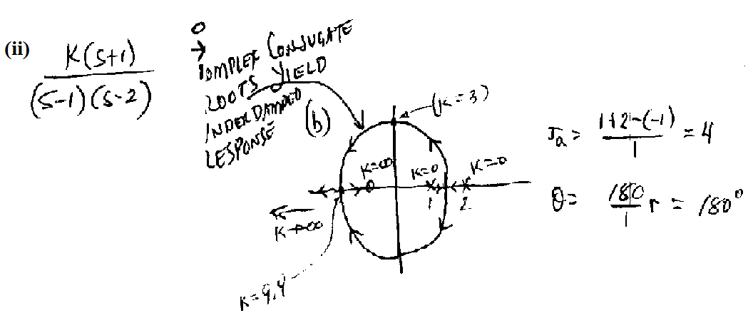
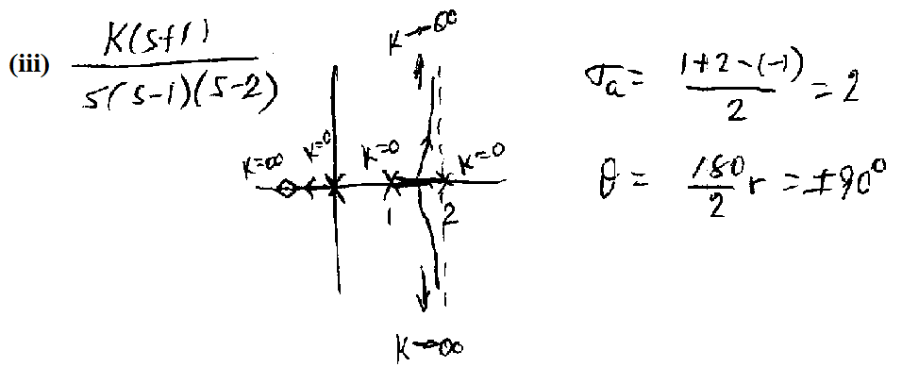
Because of the root locus typically approach the asymptotes as in (iii) , but may also lie on the asymptotes as in (i) and (ii)
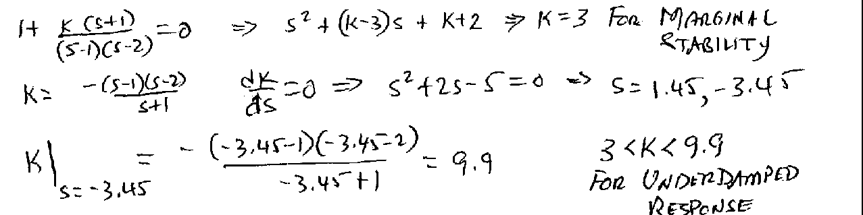
4-a ) Bode Plots of a stable plant G_{P}(s) are shown in Figure 4 below. Design a proportional controller G_{c}(s) = K, so that the steady state error for a unit step input is as small as possible, and the gain margin of the feedback system is greater or equal to 5 db.
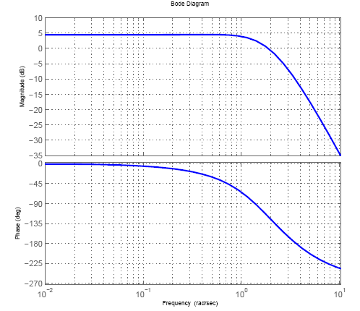
Figure 5
The proportional controller does not chsnge the phase but it does change then gain only
We can shift the Bode plot representing the gain 6db and keep a gain margin of at least 5db as shown in figure below
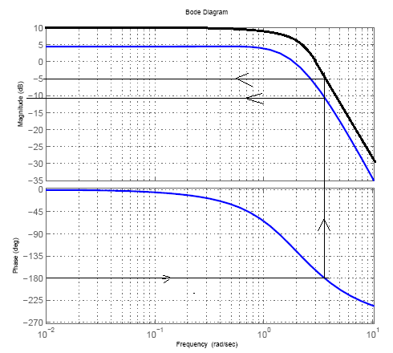
As ω tends to zero the gain approaches 10
$$∴\text{10}=\text{20}\text{log}k_{p}⇒k_{p}=3\text{.}\text{16}$$
Before the controller $k_{p}={\text{10}}^{0\text{.}2}=1\text{.}\text{585}$
The steady state error for unit input $e_{\text{ss}}=\frac{1}{1+k_{p}}$ as the system is zero type so
The steady state error is reduced from approximately 0.4 to approximately 0.25

4-b) Consider the following system where G(s) is a transfer function. Asymptotic Bode plots of G(s) is given in figure 5 below. For calculations, you may use these Asymptotic plots.
- Find the gain margin of the system.
- Find the phase margin of the system.
- Find the transfer function of the system. .
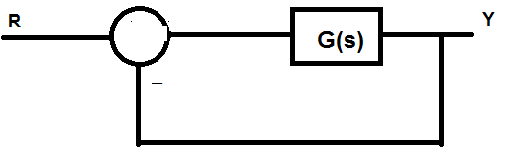

GOOD LUCK

