جامعة بنها - كلية الهندسة ببنها - قسم الهندسة الكهربية
الإجابة النموذجية لمادة تك الالات الكهربية ك 060 يوم الثلاثاء الموافق 5/1/2016
لائحة قديمة بكالوريوس ميكانيكا د شوقي حامد عرفه ابراهيم

Benha University  Benha Faculty of Engineering  Subject: Tec.Elect. Mach. (E 60) |   Time: 3hour  Forth Year 5-1-2016    Mech. Eng. Dept.
Solve & draw as much as you can (questions in two pages)

Question (1) [15] Points
1.a) Explain the hysteresis and eddy-current losses?
1.b) A magnetic circuit has a mean length of 1 m and a cross sectional area of 0.06 m², and a relative permeability of 2500. A magnetizing coil of 100-turns and 10 Ω is connected to a DC circuit causes a 50 V drop across the coil.
Determine the flux and flux density in the core?

Question (2) [15] Points
2.a) What is meant by voltage regulation of a transformer?
2.b) The following data were obtained from open circuit and short circuit tests of a 75 kVA, 4600─230V, 60Hz transformer and R₁=R'₂ and X₁=X'₂.
open circuit test low side | short circuit test high side
Voc=230V | Vsc=160.8V
Ioc=13.04A | Isc=16.3A
Poc=521W | Psc=1200W

Determine:
(a) the parameters of the equivalent circuit referred to high side?
(b) the load current if Z_{l}=(0.03+j0.04) Ω is connected to the low side and the input voltage is 4600V? (c) the excitation current?
P.T.O.

Question (3) [15] Points
3.a) Sketch and explain the torque-speed characteristics of a 3-phase induction motor?

3.b) A 3-phase, 230-V 30-hp, 50-Hz, six pole induction motor is operating with a shaft load that requires 20 kW input to the rotor. The rotor copper losses are 1.5 kW, and the combined friction, windage, and stray power losses for this load is 200 W.
Determine (i) shaft speed; (ii) mechanical power developed;
(iii) developed torque; (iv) shaft torque

Question (4) [15] Points
4.a) Explain the construction and theory of operation of a 3-phase Induction Motor?

4.b)A shunt generator delivers load current 60A at 400 V to a resistive load. The armature resistance is 0.2 Ω and the field resistance is 100 Ω.
Determine (i) the generated emf, (ii) armature current (iii) the efficiency?

4.c) A [15 hp, 220V, 2000 rpm ] separately excited DC motor drives a load requiring a torque of 50 Nm at a speed of 1000 rpm. R_{a}=0.25 Ω, R_{f}=147 Ω, V_{f}=220V, KФ=1.0524Nm/A.
Determine (i) the armature current and the field current? (ii)the armature voltage required? (iii) the motor efficiency? ?
With my Best Wishes

Answer
Question (1) [15] Points
1.a) Explain the hysteresis and eddy-current losses?
1.b) A magnetic circuit has a mean length of 1 m and a cross sectional area of 0.06 m², and a relative permeability of 2500. A magnetizing coil of 100-turns and 10 Ω is connected to a DC circuit causes a 50 V drop across the coil.
Determine the flux and flux density in the core?
I=E/R=50/10=5A, mmf=N*I=H*l=100*5=500=H, H=500At/m
β=μ_{o}*μ_{r}*H=4pi*10^-7*2500*500=1.57T, β=Φ/A, Φ=1.57*0.06=94.25mWb
Question (2) [15] Points
2.a) What is meant by voltage regulation of a transformer?
2-11 Voltage Regulation
The effects of leakage flux and winding resistance in a transformer cause internal voltage drops that result in different output voltages for different loads. The difference between the output voltage at no load and the output voltage at rated load, divided by the output voltage at rated load, is called the voltage regulation of the transformer, and is commonly used as a figure of merit when comparing transformers. Expressed mathematically,
 (2-44)
where:
E = voltmeter reading at the output terminals when no load is connected to the transformer
V_{rated} = voltmeter reading at the output terminals when the transformer is supplying rated apparent power
2.b) The following data were obtained from open circuit and short circuit tests of a 75 kVA, 4600─230V, 60Hz transformer and R₁=R'₂ and X₁=X'₂.
open circuit test low side | short circuit test high side
Voc=230V | Vsc=160.8V
Ioc=13.04A | Isc=16.3A
Poc=521W | Psc=1200W
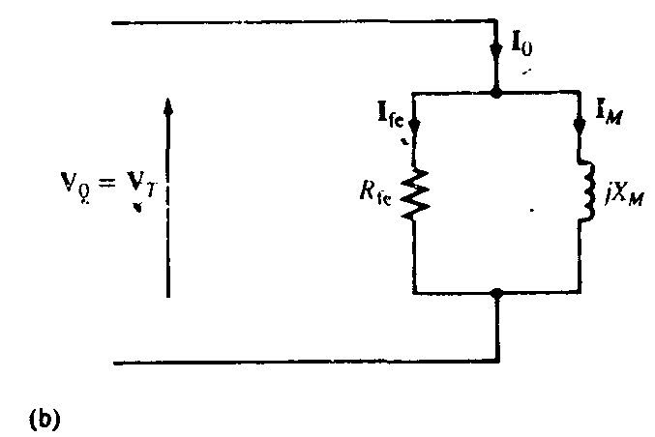
$I_{\text{SC}}=\frac{V_{\text{SC}}}{Z_{\text{eq}\text{.}\text{HS}}}P_{\text{SC}}=I_{\text{SC}}^{2}R_{\text{eq}\text{.}\text{HS}}$ $Z_{\text{eq}\text{.}\text{HS}}=\sqrt{R_{\text{eq}\text{.}\text{HS}}^{2}−X_{\text{eq}\text{.}\text{HS}}^{2}}$
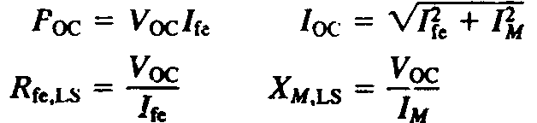
Determine:
(a) the equivalent circuit high side parameters;
(b) the load current if Z_{l}=(0.03+j0.04) Ω is connected to the low side and the input voltage is 4600V?
(c) the excitation current?
R_{fe}=(230)²/521=101.54Ω, X_{m}==(230)²/√[(230)²-(521)²]=17.91Ω
R_{eq}=1200/(16.3*16.3)=4.52Ω, Z_{eq}=160.8/16.3=9.87Ω, X_{eq}²=(9.8)²-(4.5)²=(8.8)² Ω
Z'_{L}=a² Z_{L} =12+j16, Z'_{in}= 16.52+j124.8Ω
I_{o}=(4600/101.54)+ (4600/ j 17.91)=45.3-j256.84=260.8∟-80A
I'_{'L}=(4600/16.52)+ (4600/ j 24.8)=278.5-j185.5=334.62∟-33.7A
Question (3) [15] Points
3.a) Sketch and explain the torque-speed characteristics of a 3-phase induction motor?
3.b) A 3-phase, 230-V 30-hp, 50-Hz, six pole induction motor is operating with a shaft load that requires 20 kW input to the rotor. The rotor copper losses are 1.5 kW, and the combined friction, windage, and stray power losses for this load is 200 W. Determine (i) shaft speed; (ii) mechanical power developed;
(iii) developed torque; (iv) shaft torque
S=1500/20000=0.075, n_{s}=120*50/6=1000rpm, ω_{s}=1000*pi/30=104.7rad/s
n_{r}=(1-S)ns=(1-0.075)1000=925rpm, ω_{r}=925*pi/30=97rad/s
P_{mech}=(1-0.075)20000=18500W, T_{mech}=18500/97=191Nm
P_{shaft}= 18500-200=18300W, T_{shaft}=18300/97=189Nm

Question (4) [15] Points
4.a) Explain the construction and theory of operation of a 3-phase Induction Motor?
4.b)A shunt generator delivers load current 60A at 480 V to a resistive load. The armature resistance is 0.2 Ω and the field resistance is 100 Ω.
Determine (i) the generated emf, (ii) armature current (iii) the efficiency?

I_{f}=480/100=4.8A, I_{a}=60+4.8=64.8A, E_{a}=480+64.8*0.2=492.96V
P_{inp}=492.96*64.8=31943.8W, P_{out}=480*60=28800W, η=28800/31943.8=90.2%

4.c) A [15 hp, 220V, 2000 rpm ] separately excited DC motor drives a load requiring a torque of 50 Nm at a speed of 1200 rpm. .
Determine (i) the armature current and the field current? (ii)the armature voltage required? (iii) the efficiency? ?
I_{f}=220/147=1.5A, I_{a}=50/1.0524=47.51A, E_{a}=1.0524*2pi*1200/60=132.3V
Va=E_{a}+IaRa=132.3+47.51*0.25=144.2V, P_{inp}=144.2*47.51+1.5*220=7179.9W, P_{out}=50*2pi*1200/60=6283.2W, η=6283.2/7179.9=88%

