نموذج أسئلة و اجابة مادة ميكانيكا الموائع م 1111
تاريخ الامتحان الخميس 4 يناير 2018
استاذ المادة أ.د محمد عبد اللطيف الشرنوبى
Benha University

College of Engineering at Benha

Department of Mechanical Eng.

Questions For Final Examination

Subject: Fluid Mechanics M1111 January/4/2018

First year Mech. Time :180 min.

Examiner:Dr.Mohamed Elsharnoby
Attempt all questions Number of questions = 5 Number of pages = 2

1-a) Define, give examples and draw the figure of shear stress vs. rate of shear strain δu/δy for : Newtonian fluid, pseudo plastic, dilatant, plasic, bingham plastic, and ideal fluid. Define and give examples Thixotropic and Rheopectic fluids.
- A soap bubble 50 mm in diameter contains a pressure (in excess of atmospheric) of 2 mbar. Find the surface tension in the soap film.
- Define the compressibility of a fluid and derive an expression for the isothermal compressibility of a perfect gas.
2-a) A uniform film of oil 0.13 mm thick separates two discs, each of 200 mm diameter, mounted co-axially. Ignoring edge effects, calculate the torque necessary to rotate one disc relative to the other at a speed of 7 rev/s if The clearance is filled with oil at 20ºC with ν = 0.1 Stokes and SG = 0.9.
b) Calculate the pressure, in kPa, at A, B, C, and D in Figure 1.
c) A tank holding water has a triangular gate, hinged at the top, in one wall (figure 2).
Find the moment at the hinge required to keep this triangular gate closed.
3-a) Sketch the temperature variation with altitude for the international standard atmosphere (ISA).
b) The tank of water in Fig.3 is moving with constant acceleration up a 30º inclined plane. Compute (i) the acceleration a ,(ii) whether the acceleration is up or down, and ( the maximum pressure in the tank.
c) A uniform wooden beam of 10 cm by 10 cm cross-section and 10 m long. The beam is hinged from a point 1m above water level (Figure 4). At what angle will the beam float in water if its SG = 0.65 ? (Hint: find H then find Ɵ).
4-a)) Define center of Bouancy, Meta center, Metacentric radius and Explain the stability of immersed and floatin bodies.

b)Define i) uniform flow ii) Streamline iii) Streakline iv) Potentail flow v) vorticity vi) circulation (give the mathematical expression) .
c) Given the velocity field V = 13x² yi+18(yz+x)j+15k, find the vorticity and the angular velocity vector at (2,3,4).

5-a) Water flows steadily through the variable area vertical pipe shown in figure 5. The velocity is given by V = 10(1+x) m/sec, where x in meter. Viscous effects are neglected. (i) Determine the pressure gradient, ∂p/∂x, as a function of x) needed to produce this flow. (ii) If the pressure at section (1) is 3 bars, determine the pressure at section (2) by inteegration of the pressure gradient obtained in (i) and by applying Bernoulli Equation.

b) When the pump in Fig. 6 draws 220 m³/hr of water from the reservoir, the total friction head loss head is 5 m. The flow discharges through a nozzle to the atmosphere Estimate the pump power in kW.
c)Deduce an expression for the discharge of water over a right-angled sharp edged V-notch, given that the coefficient of discharge is 0.61.A rectangular tank 16m by 6m has the same notch in one of its short vertical sides. Determine the time taken for the head, measured from the bottom of the notch, to fall from 15cm to 7.5cm. (Figure 7).
* * * G O O D L U C K * * *
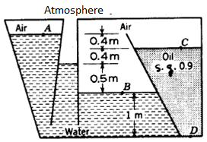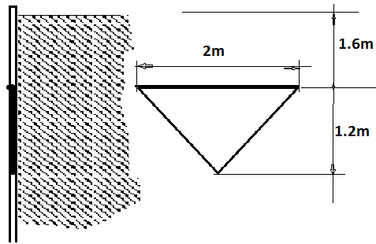
Figure 1 Figure 2

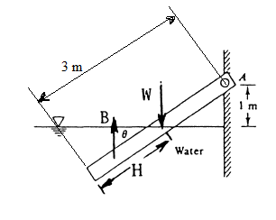
Figure 3 Figure 4

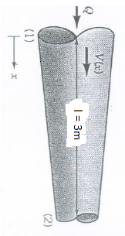
Figure 5 Figure 6

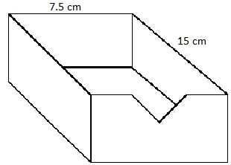
Figure 7

College of Engineering at Benha

Department of Mechanical Eng.
مادة ميكانيا الموائع كود م 1111 Subject: Fluid Mechanics
Model Answer of the Final Exam
Date of the Exam Jan./ 4/2018
نموذج أسئلة و اجابة مادة ميكانيكا الموائع م 1111
تاريخ الامتحان الخميس 4 يناير 2018
استاذ المادة أ.د محمد عبد اللطيف الشرنوبى
Elaborated by: Dr. Mohamed Elsharnoby

1-a) The relationship between shear stress and the velocity gradient (rate of shear strain) in the fluid. These relationships can be seen in the graph below for several categories
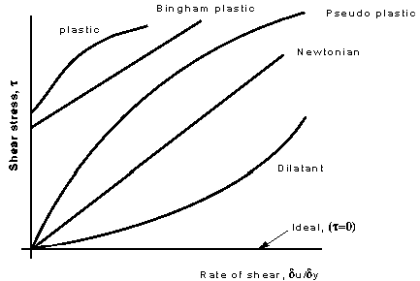
Figure 1 Shear stress vs. Rate of shear strain δu/δy
Newtonian fluids:
Fluids which obey the Newton's law of viscosity are called as Newtonian fluids. Newton's law of viscosity is given by
τ = μ du/dy, where τ = shear stress and μ = viscosity of fluid
du/dy = shear rate, rate of strain or velocity gradient
All gases and most liquids which have simpler molecular formula and low molecular weight such as water, benzene, ethyl alcohol, CCl₄, hexane and most solutions of simple molecules are Newtonian fluids.
Properties are independent of time under shear.
Bingham-plastic: Resist a small shear stress but flow easily under larger shear stresses. e.g. tooth-paste, jellies, and some slurries.
Pseudo-plastic:
Most non-Newtonian fluids fall into this group . No minimum shear stress necessary and the viscosity decreases with rate of shear, e.g. polymer solutions, blood, colloidal substances like clay, milk and cement.. Pseudo plastic fluids are also called as Shear thinning fluids. At low shear rates (du/dy) the shear thinning fluid is more viscous than the Newtonian fluid, and at high shear rates it is less viscous.
  - Dilatant fluids: Viscosity increases with increasing velocity gradient. They are uncommon, but suspensions of starch and sand behave in this way. Dilatant fluids are also called as shear thickening fluids. ; Viscosity increases with rate of shear e.g. quicksand.
  - Thixotropic fluids e.g. thixotropic jelly paints.
Rheopectic fluids:. e.g. gypsum suspension in water.

1-b) Similar treatment can be made for a soap bubble which is having two free surfaces.
Δp = 4 σ /r σ = Δpxr/4 σ = 2x10⁻³x10⁵x25x0⁻³/4 = 1.25 N/m

1-c) Compressibility is sometimes defined as the relative change in fluid volume for an applied pressure change.
Then compressibility (K) = - (1/Vo) . (ΔV / Δp)
where, Vo = original volume, ΔV = volume change, Δp = pressure change .
The reciprocal of K is the bulk modulus of elasticity (Ev), where
Ev = - Δp Vo/ΔV .
The fundamental equation for the change of state of a perfect gas is given by the relationship :
pV^{n}= p1V1^{n} = p2V2^{n} or, p / ρ ^{n} = constant
K = 1/P

2-a
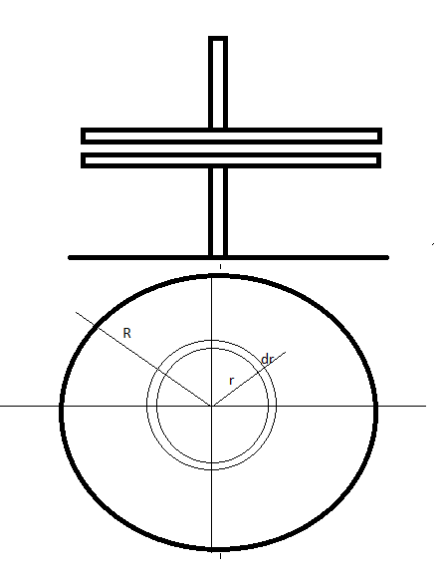
Figure 2
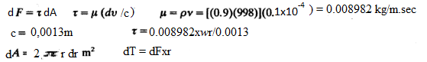
Integrating to get the torque T =1/4R⁴wx(0.008982/0.0013) x2π = 0.0076 N.m

2=b

Figure 3
2-c
3-a
Figure 4

3-b)
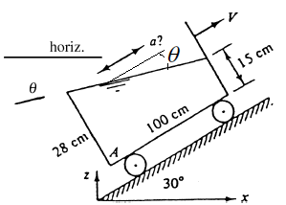

Figure 6

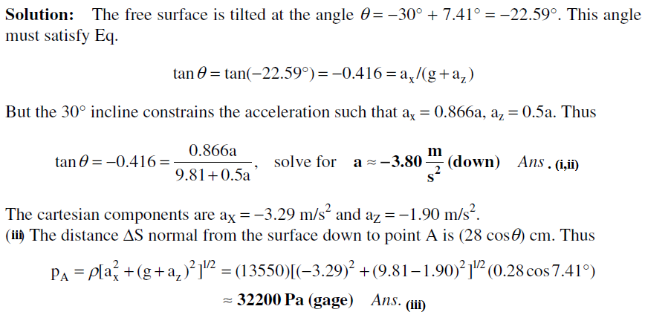

3-c Solution: The total beam volume is 3(.1)2 = 0.03 m³, and therefore its weight is W = (0.65)(9790)(0.03) = 190.9 N, acting at the centroid, 1.5 m down from point A. Meanwhile, if the submerged length is H, the buoyancy is B = (9790)(0.1)²H = 97.9H Newton, acting at H/2 from the lower end. Sum moments about point A:
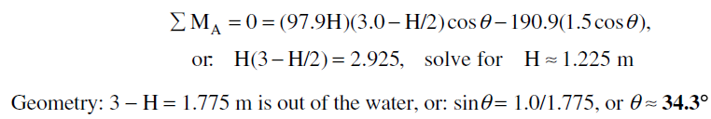
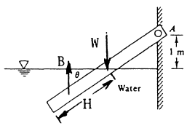
Figure 5

4-a)
Center of Bouncy is the point of action of the up thrust acting on the floating or immersed bodies..
A vertical line drawn upward from B_ intersects the line of symmetry at a point M, called the metacenter. Distance between center of bouncy and the metacenter is the metacentric radius.
Condition of stability for immersed bodies is that center of buoyancy B should be above the center of gravity G.
Condition of stability for floating bodies is that metacenter M should be above the center of gravity G .
Stability Of Submerged And Floating Bodies
For stability of a submerged body, the body’s center of gravity must lie directly below the center of buoyancy (gravity) of the displaced liquid. If the two points coincide, the submerged body is in neutral equilibrium for all positions.
For stability of a floating cylinder or sphere, the body’s center of gravity must lie below the center of buoyancy.
Stability of other floating objects will depend upon whether a righting or overturning moment is developed when the center of gravity and center of buoyancy move out of vertical alignment due to shifting of position of the center of buoyancy. The center of buoyancy will shift if the floating object tips, because the shape of the displaced liquid changes and hence its center of gravity shifts.
Figure 6 (a) shows a floating body in equilibrium, with its center of gravity (CG) located directly above the center of buoyancy (CB). If the CG is to the right of the line of action of the buoyant force when the body is rotated slightly counterclockwise as in Fig. 6 (b), the floating body is stable. If instead the CG is to the left of the line of action of the buoyant force as in Fig. 6-1(c), the floating body is unstable. This differentiation between stability and no stability can also be made by referring to the point of intersection of the vertical axis (A-A) and the line of action of the
Buoyant
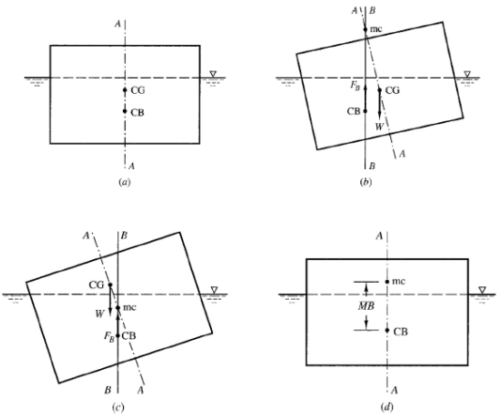
Figure 6

force (B-B). This point of intersection is known as the metacenter (mc). It is clear from observing Figs. 4 (b) and (c) that a floating body is stable if its CG is below the mc and unstable if its CG is above the mc.

A vertical line drawn upward from B_ intersects the line of symmetry at a point M, called the metacenter.
Stability of floating bodies
There are two cases
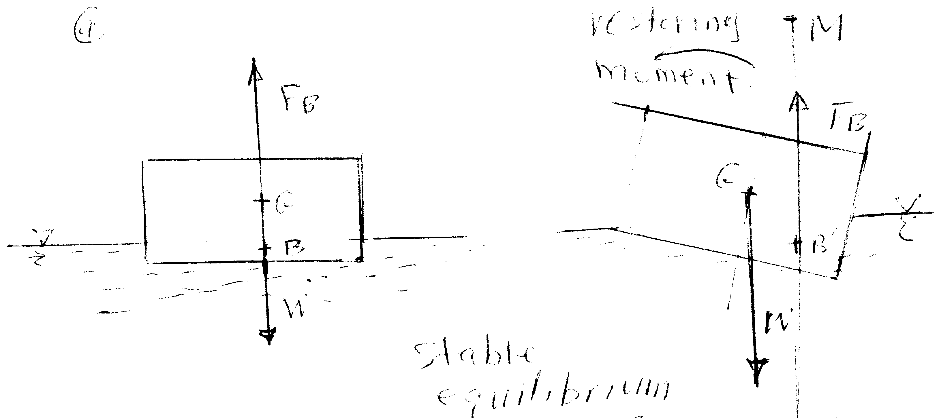
Figure 7-a
Case 1: Stable equilibrium , when the floating body is tilted to the right, a couple is created due to the deviation between the lines of actions of weight and buoyant force. This moment restore the body to its original position when the metacenter, M, is above the center of gravity, G.(figure 7-a)
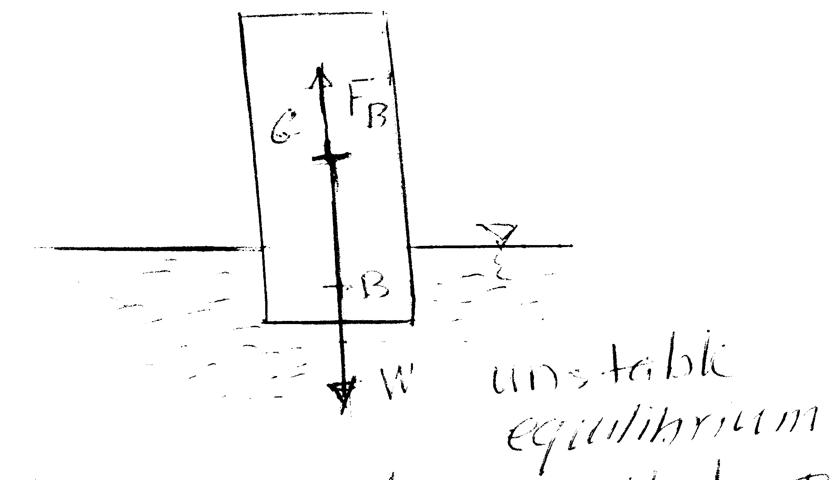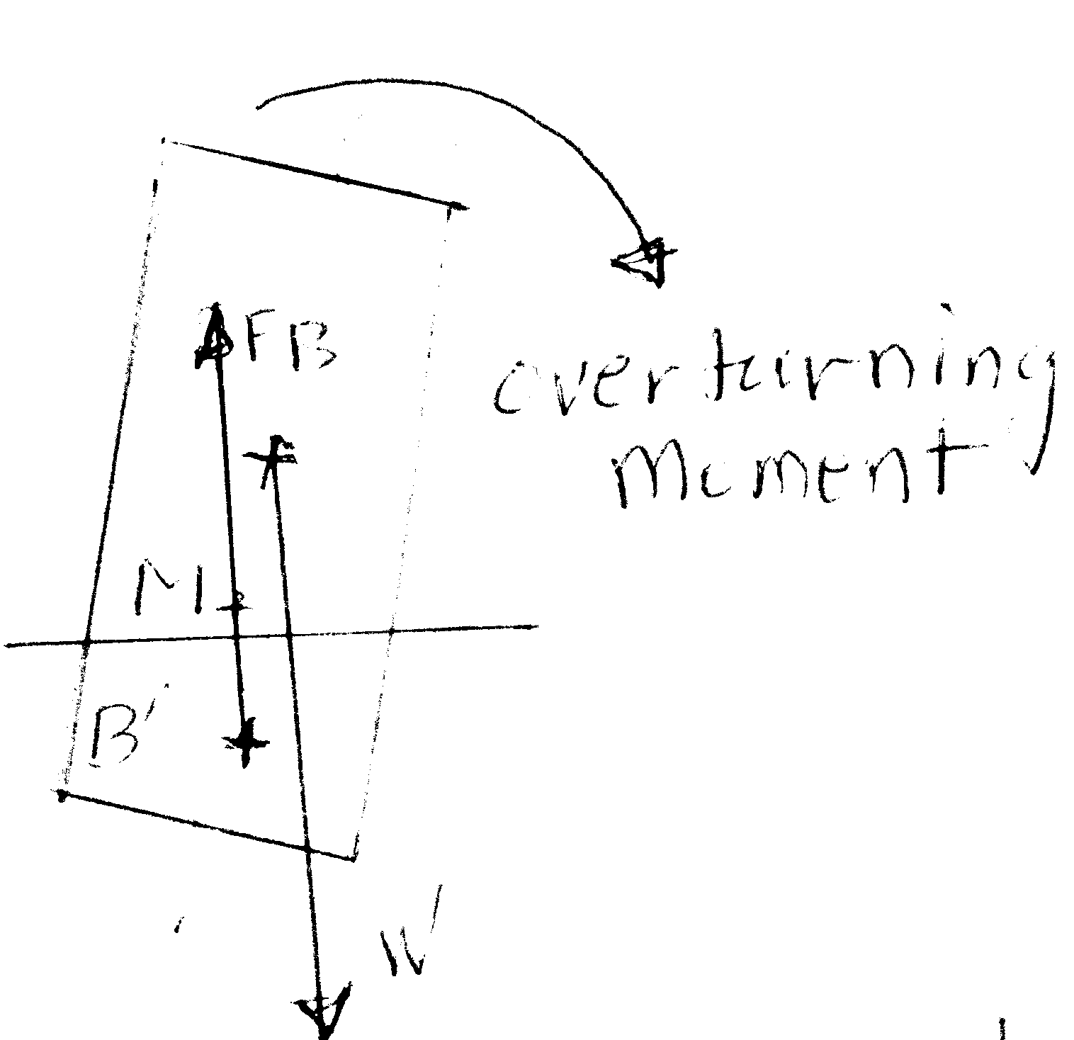
Figure 7-b
Case 2: Unstable equilibrium, when the floating body is tilted to the right, a couple is created due to the deviation between the lines of actions of weight and buoyant force. This moment turn the body over to when the metacenter, M, is below the center of gravity, Figure 7-b

4-b
i- Uniform flow is the flow whose velocity is the same at all points in the flow field (Velocity is independent on position).
ii) Streamline - An imaginary line in the flow that is everywhere parallel to the local velocity vectors.
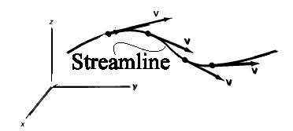
Figure 6
- Streakline - An instantaneous line composed of all particles originating from a given point in the flow field; or is the locus of particles which have earlier passed through a prescribed point in space.

iv) Potential flow is the flow which has zero vorticity.
Potential flow: Flow whose vorticity equal zero or Curl V = 0, where the vector operation () is referred to as the curl of the velocity vector V. The vorticity vector, ζ, is defined as twice the rotation vector:
v) Circulation is defined as the line integral around the curve of the arc length ds times the tangential component of velocity. Shear stress for the element is thus given by
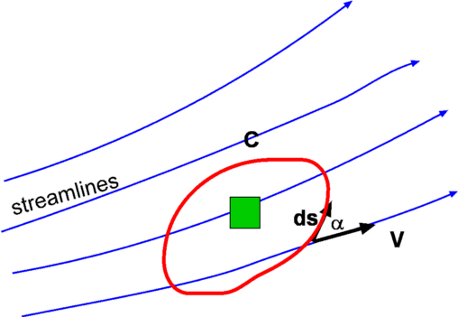
Figure 7: Definition of Circulation
Figure 7: Definition of Circulation
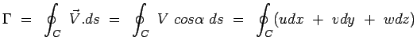
4-c)
5-a) 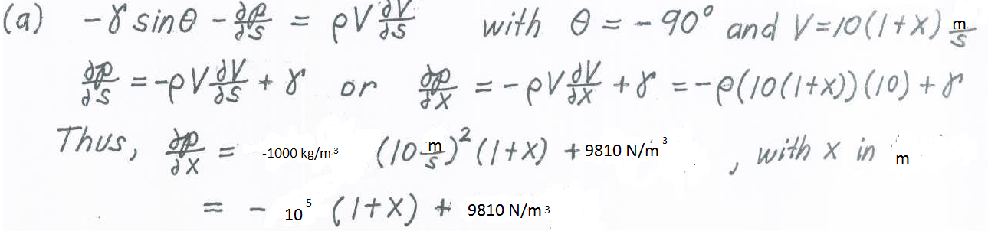
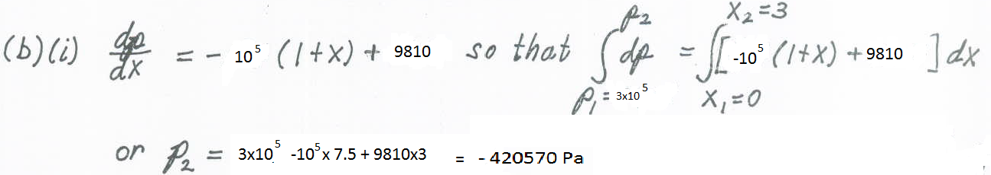
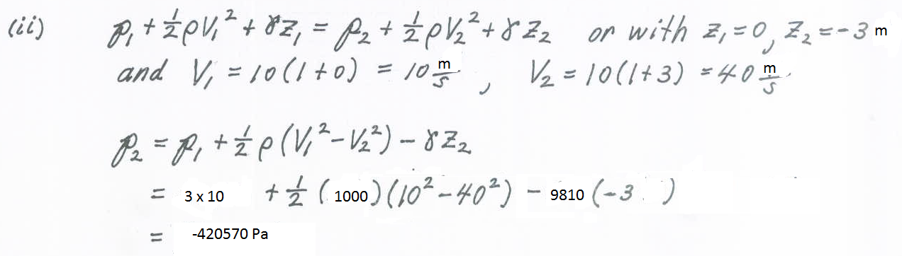
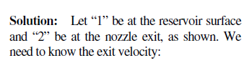
As shown in Figure 8
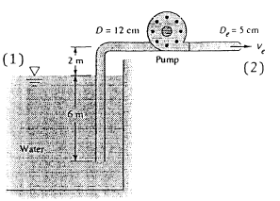
Figure 9
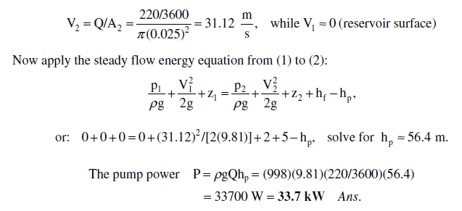
5-bFrom your notes you can derive:
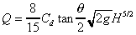, For this weir the equation simplifies to
, Write the equation for the discharge in terms of the surface height change:
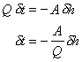Integrating between h₁ and h_{2,} to give the time to change surface level
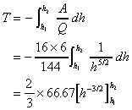
h₁ = 0.15m, h₂ = 0.075m
