نموذج أسئلة و اجابة مادة الاقتصاد الهندسى م561
أستاذ المادة : د. محمد عبد اللطيف الشرنوبى

Benha University College of Engineering at Benha

Questions For Final Examination Time :120 min.

Subject: Engineerin Economy M561 January/17/ 2018

Fifth year Structural and production engineering

Examiner:Dr.Mohamed Elsharnoby

To purchase an used automobile, $6000 is borrowed immediately. The repayment schedule requires equal monthly payments of $264.72 to be made over the next 24 months. After the last payment is made, any remaining balance on the loan will be paid in a single lump sum. The effective annual rate of interest is 19.56% based on monthly compounding. Find the nominal interest rate and the lump sum paid at the end of the loan.
(8 points)
2-Suppose that the parents of a young child decide to make annual deposits into a savings account, with the first deposit being made on the fifth birthday and the last deposit being made on the fifteenth birthday. Then starting on the child’s eighteenth birthday, withdrawals shown below will be made. If the effective interest rate is 8% during this period of time, what are the annual deposits in years five through fifteen? (10 points)

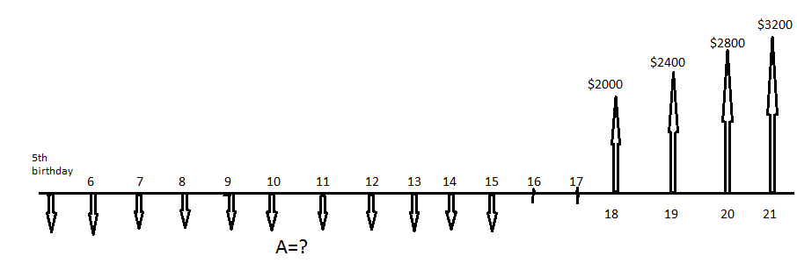

3-A quarry outside of Austin, Texas wishes to evaluate two similar pieces of equipment by which the company can meet new state environmental requirements for dust emissions. The MARR is 12% per year. Determine which alternative is economically better using (a) the AW method, and (b) AW method with a 3-year study period. (10 points)
Equipment X Y
First cost, $ 40,000 75,000
AOC, $ per year 25,000 15,000
Life, years 4 6
Salvage value, $ 10,000 7,000
Estimated value after 3 years, $ 14,000 20,000

4) Suppose that your salary is $35,000 in year one, will increase at 6% per year through year four, and is expressed in actual dollar as follows:
End of year, K Salary (A$)
- $ 35,000
- 37,100
- 39,326
- 41,685
If the general price inflation rate (f) is expected to average 8%per year, what is the real dollar equivalent of these actual dollar salary amounts? Assume that the base dollar value is at year one (K=1) (10 points)

5-Pima County is considering three mutually exclusive projects which will add to its equipment’s maintenance facilities. Characteristics are as follows, with money figures in thousands of dollars.
Project 1 Project 2 Project 3
Initial cost 500 600 700
Life(years) 10 15 30
Annual cost savings 100 125 160
Annual maintenance cost 50 45 60
Salvage value 200 250 310
_______________________________________________________________________
If the opportunity cost of the capital of the county is 11%, which alternative, if any, should be chosen? Ignore inflation for the moment and use the Benefit to cost ratio method. (10 Points)
6. Consider the following two investment alternatives.

Alternative A Alternative B

Initial Investment $20,000 $ 10,000

Service Life 5 years 5 years

Salvage Value 0 0

Depreciation method SL SL
Estimated operating costs and revenues (profits).

End of Year

1 2 3 4 5
Alternative  A | Operating cost  Revenue(profit) | $ 10,000 $ 10,500 $ 11,000 $ 12,000 $ 14,000  15,000 15,900 17,000 17,500 9,000
Alternative  B | Operating cost  Revenue(profit) | $ 1,200 $ 1,000 $ 1,500 $ 1,300 $ 1,200  4,200 4,000 4,500 4,300 4,200

If the tax rate is 30%

For the actual dollar cash flow given above find the after tax ROR for alternative B when an average inflation rate of 7% is considered.

Which alternative is more attractive to undertake when the effective tax rate is only considered ( no inflation) ? (12 points)
G O O D L U C K
Note: A table of formulae are on the back of the questions if you need.
- Single Payment formulas:
Compound amount: F = P (1+i)^{n} = P (F/P,i,n)
Present worth: P = F (1+i)^{-n} = F (P/F,i,n)
- Uniform Series Formulas:
Compound Amount: F = A{[(1+i)^{n} –1]/i} = A (F/A,i,n)
Sinking Fund: A = F {i/[(1+i)^{n} –1]} = F (A/F,i,n)
Capital Recovery A = P {[i(1+i)^{n}]/[(1+i)^{n} – 1] = P (A/P,i,n)
Present Worth:P = A{[(1+i)^{n} – 1]/[i(1+i)^{n}]} = A (P/A,i,n)
- Arithmetic Gradient Formulas:
Present Worth P = G {[(1+i)^{n} – i n – 1]/[i² (1+i)^{n}]} = G (P/G,i,n)
Uniform Series A = G {[(1+i)^{n} – i n –1]/[i (1+i)^{n} – i]} = G (A/G,i,n)
- Geometric Gradient Formulas:
If i ≠ g, P = A {[1 – (1+g)^{n}(1+i)^{-n}]/(i-g)} = A (P/A,g,i,n)
If i = g, P = A [n (1+i)⁻¹] = A (P/A,g,i,n)
- Nominal interest rate per year, r : the annual interest rate without considering the effect of any compounding
- Effective interest rate per year, i_{a}:
i_{a} = (1 + r/m)^{m} – 1 = (1+i)^{m} – 1 with i = r/m
- Continuous compounding, :
r – one-period interest rate, n – number of periods
(P/F,r,n)^{inf}= e^{-rn}
(F/P,r,n)^{inf}= e^{rn}

نموذج الاجابة المادة :اقتصاد هندسى م 561 الغرقة الخامسة
التاريخ الأربعاء 17 يناير 2018
أستاذ المادة : د. محمد عبد اللطيف الشرنوبى

Problem #1
The effective interest i _{effective} = (1+i_{nominal}/12)¹²-1 = 0.1956
i_{nominal}/12 = 0.01499871446118510601044945566619
i_{nominal} = 18%

P = A(P/A,1.5%,24) =
Present Worth:P = A{[(1+i)^{n} – 1]/[i(1+i)^{n}]} = A (P/A,i,n)
P= 264.72 *20.03044476 = 5302.46
The present value of the lump = 6000-5302.46 = $697.54
The final value is F = P (1+i_{eff})² = $ 997.1
The Lump sum paid = F + A = 997.1 + 264.72 = $ 1261.82

2-
Assume the final values of the series of payments is F₁ and the value of the withdrawals at the 17th birthday is P₁
F₁=P₁/(1+i)²
F₁= A (F/A,i,n)= A (F/A,8%,11)= 16.6455A
P₁=2000 (P/A,8%,4) +400 (P/G,8%,4)=2000x3.3121+400x4.6501
=6624.2 +1860.04=8484.24
F₁= 16.6455A=7273.8683
A=436.985=437

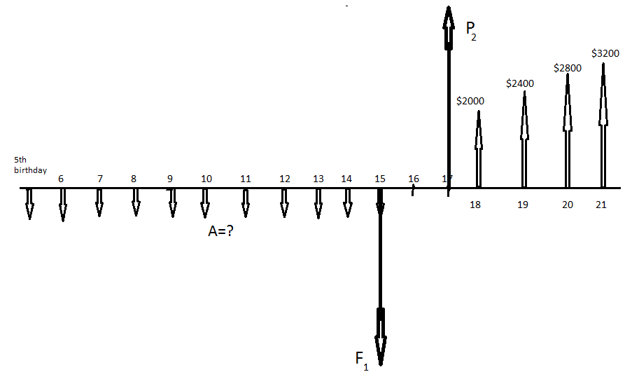

3-
4-
End of year, K Salary (A$) Salary(R$)
- $ 35,000 $35,000
- 37,100 34,351.85
- 39,326 33,715.70
- 41,685 33,090.90

Problem 5

The Annual cost of each project is :
The Annual cost of project 1 = 500(A/P,0.11,10) + 50
= 500 x 0.1698 + 50 = $ 134.9
The Annual saving of project 1 =200(A/F,0.11,10) + 100
= 200x0.0598 +100 = $ 119.6

The Annual cost of project 2 = 600(A/P,0.11,15) + 45
= 600 x 0.13906 + 45 = $ 128.44
The Annual saving of project 2 =250(A/F,0.11,15) + 125
= 250x0.02906 +125 = $ 132.266
The Annual cost of project 3 = 700(A/P,0.11,30) + 60
= 700 x 0.11502 + 60 = $ 140.52
The Annual saving of project 3 =310(A/F,0.11,30) + 160
= 310x0.0048 +160 = $ 161.49

The saving is to be considered as Benefit

Project 1 Project 2 Project 3
So B/C 0.8866 1.0298 1.14923

Project 1 is rejected
The best is Project 3 as
∆B/∆C between project 2 and project 3 is =29.224/12.04 = 2.419

6. Consider the following two investment alternatives.

Alternative A Alternative B

Initial Investment $20,000 $ 10,000

Service Life 5 years 5 years

Salvage Value 0 0

Depreciation method SL SL
Estimated operating costs and revenues (profits).

End of Year

1 2 3 4 5
Alternative  A | Operating cost  Revenue(profit) | $ 10,000 $ 10,500 $ 11,000 $ 12,000 $ 14,000  15,000 15,900 17,000 17,500 9,000
Alternative  B | Operating cost  Revenue(profit) | $ 1,200 $ 1,000 $ 1,500 $ 1,300 $ 1,200  4,200 4,000 4,500 4,300 4,200

If the tax rate is 30%

For the actual dollar cash flow given above find the after tax ROR for alternative B when an average inflation rate of 7% is considered.

Which alternative is more attractive to undertake when the effective tax rate is only considered ( no inflation) ? (12 points)

We construct the following table for alternative B.6 #
The net cash received should be the difference between the annual revenue and operating cost
Using the straight line depreciation
SL depreciation = (10000)/5 = $2000 per year.
Constructing the table representing the cash flow before and after taxes as the following:

Year | CF before taxes | SL Depr. | Taxable Inc. | Tax (30%) | CF after taxes
 | (a) | (b) | (c) = (a) – (b) | (d) = -40%(c) | (a) + (d)
0 | -$10,000 |  |  |  | -$10,000
1 | 3000 | 2000 | 1000 | -300 | 2700
2 | 3000 | 2000 | 1000 | -300 | 2700
3 | 3000 | 2000 | 1000 | -300 | 2700
4 | 3000 | 2000 | 1000 | -300 | 2700
5 | 3000 | 2000 | 1000 | -300 | 2700

To determine the IRR ,it is so easy here as the annual receipts are constant so we have
(A/P,i,5) =2700/10000 = 0.27. From tables (A/P,11,5) = 0.2706, (A/P,10,5) = 0.2638
Then IRR after tax =10.9%
Before Tax ROR I = 15.3%
After tax and include 6% inflation rate is considered then the real interest rate is $i^{,}=\frac{i−f}{1+f}=4\text{.}\text{62}\text{\%}$
We construct the following table for alternative A.
The net cash received should be the difference between the annual revenue and operating cost
Using the straight line depreciation
SL depreciation = (20000)/5 = $4000 per year.
Constructing the table representing the cash flow before and after taxes as the following:

Year | CF before taxes | SL Depr. | Taxable Inc. | Tax (40%) | CF after taxes
 | (a) | (b) | (c) = (a) – (b) | (d) = -30%(c) | (a) + (d)
0 | -$20,000 |  |  |  | -$20,000
1 | 5000 | 4000 | 1000 | -300 | 4700
2 | 5400 | 4000 | 1400 | -420 | 4980
3 | 6000 | 4000 | 2000 | -600 | 5400
4 | 5500 | 4000 | 1500 | -450 | 5050
5 | 5000 | 4000 | 1000 | -300 | 4700

To determine the IRR ,it is so obvious that the maximum net profit after tax is 5400 , so the (A/P,i,5) $0\text{.}\text{27}$consequently i$\text{10}\text{.}9\text{\%}$ . Choose alternative B.

