Benha University Semester ❶ (Electro Mechanical Prog.)
Faculty of Engineering Engineering Graphics (FRM109)
Mechanical Engineering Department Spring Semester 2019- 2020

Term Exam.  Time all : 2 Hrs

- Assume any missing Dimensions.
- Draw with suitable scale.
- Attempt all questions.
- Don’t erase the working details.
- Dimension the drawing.
- N.B. The examination consists of two questions on one page.
________________________________________________________________________________________________
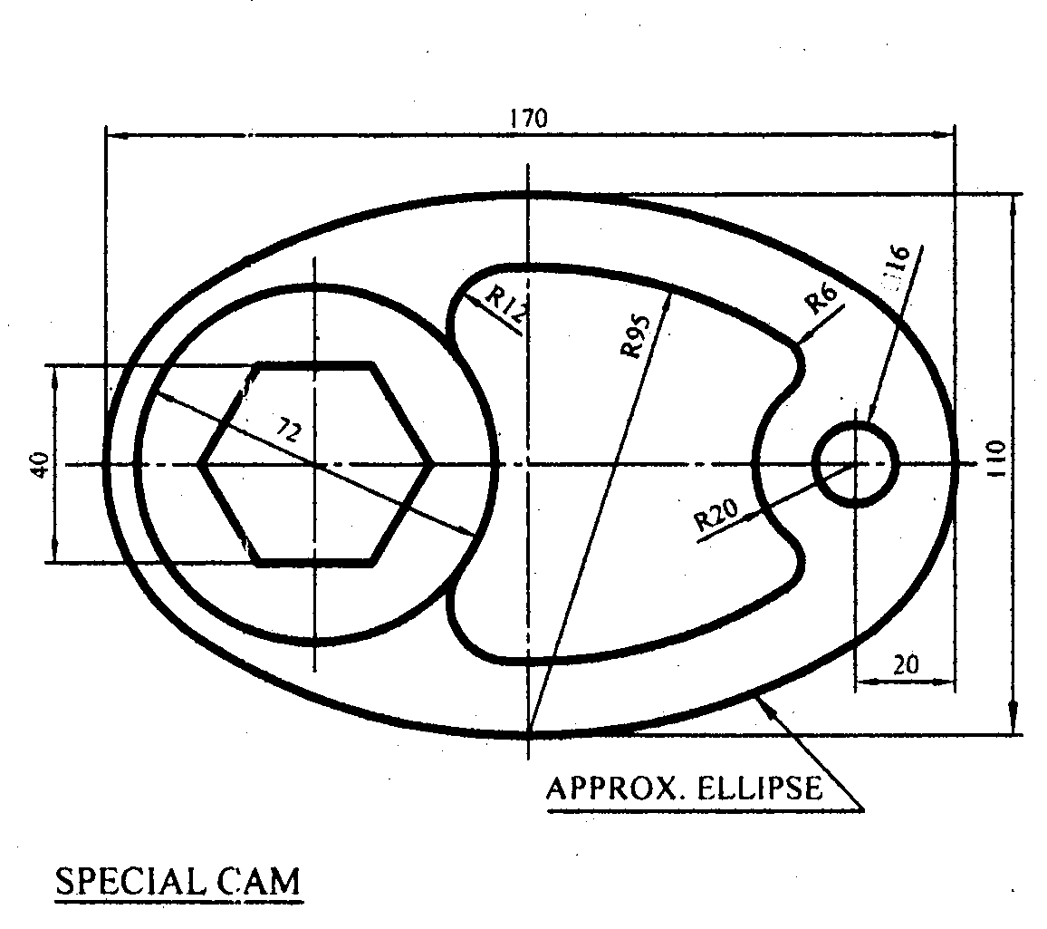
Question ❶

Draw the contour lines of the part
shown in Figure (1)
.

Figure (1)
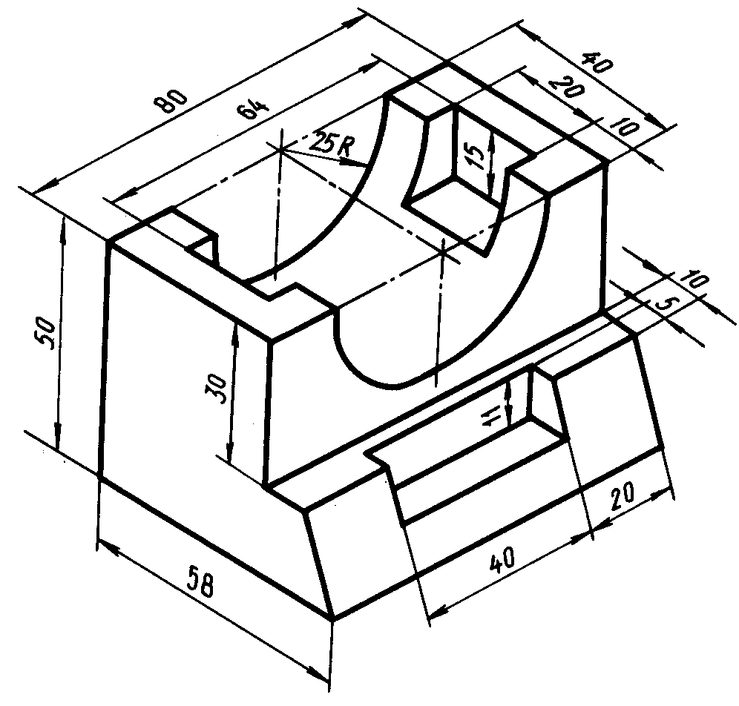

Question ❷

Redraw the given Isometric shown in Figure (2).

Figure (2)

