Benha University 2nd year (General Mechanics)
Benha Faculty of Engineering Machine Design (M1262)
Mechanical Engineering Department Spring Semester 2019- 2020

Term Exam. Time all. 3 hrs
02/ 05/ 2020

Students may assume any missing data

Question  [60 marks]
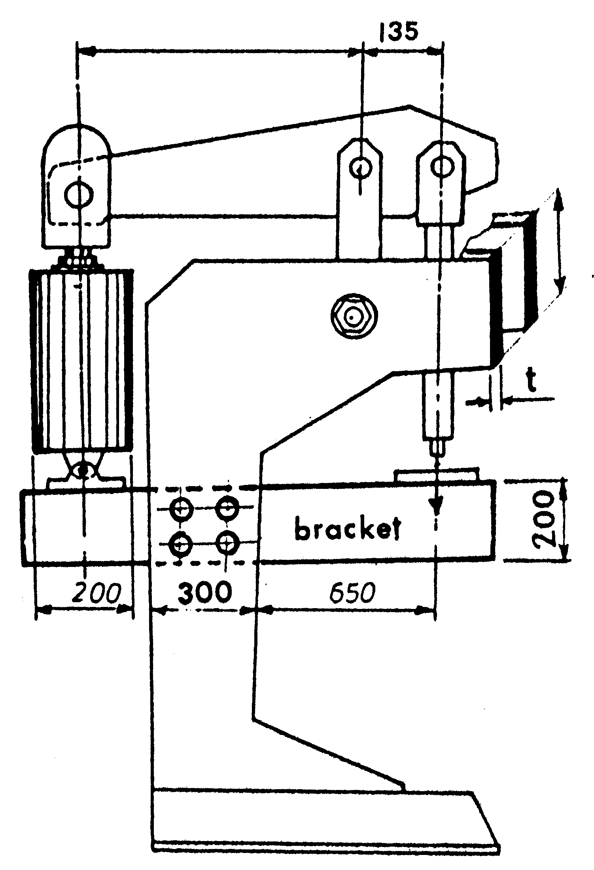
a) Prove that, for No separation in a hydraulic cylinder the tightening up force Q of the bolts must be ≥ F_{bolt} ( c_{j} / c_{b}+c_{j} ).
b) An air – operated punch press similar to the one shown in Figure (1). Let the depth of throat to the inside edge of the frame be 65cm., the diameter and stroke of the piston about 20x20 cm., the mechanical advantage of the lever about 7, and the force at the punch is required to punch a steel sheet (St42) of 2mm thickness and the diameter of the punch 10 mm.
- Determine:
  - the horizontal section of the frame, and locate and design the cylinder and the piston rod.
  - The diameter of the bollts which hold the cylinder covers.
  - for the bracket, design the bolted joint.
- Make a complete construction drawing for the air cylinder, put the suitable fits (free hand sketch) .
Figure (1)

Take [ c_{b} = 0.5, c_{j} = 0.19 and μ = 0.25 ]
N. B. The J.B. Johnson formula :
F _{crit.} = A σ_{y} [ 1- (σ_{y} L² / 4 n π² E R² )]
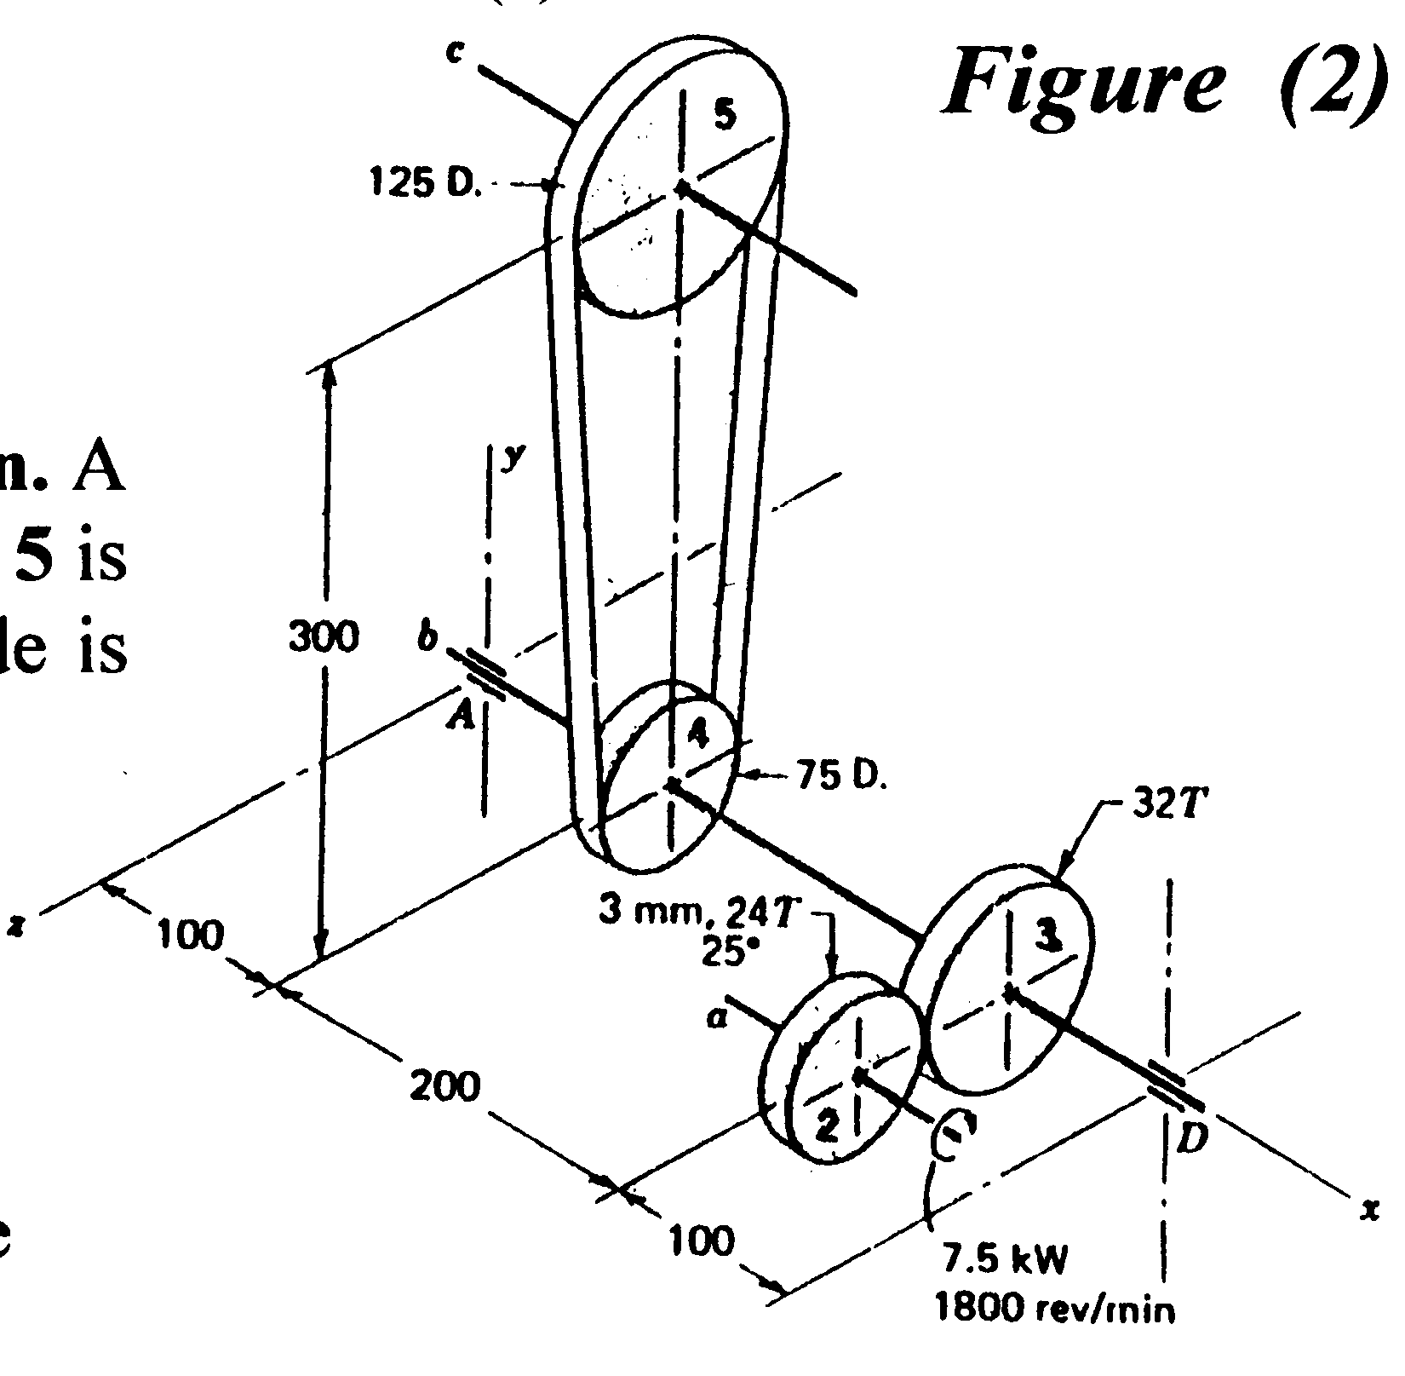
The Euler formula :

F _{crit.} = n π² E I / L² ( E = 2.1 x 10⁶ kg/cm² for steel )
Question  [30 marks]

A 7.5 kW motor drives gear 2 in figure (2) at 1800 rev/min. A flat belt on pulley 4 drives pully 5. The shaft to which pully 5 is attached drives a blower. The belt tension on the loose side is 20 percent of the tension on the tight side
You are required to:
a) Design the shaft AD
b) Select the sutable key for the pulley 4
c) Make a working drawing for the pulley 4, put the
suitable tolerances and surface finish marks.
d)Select the suitable bearings for the line shaft.
Figure (2)

Table (1) : Metric thread series A, Selection from CSN 01 4014

